



| 50 Coding Templates for HTML, CSS,  and JavaScript |
| --- |



You can edit your own version of this document in one of two ways:

1. Edit this version to fit your needs
2. Go to “File” > “Download As” > “Microsoft Word” to Download

How to Use These Templates

Copy and paste these code templates into your CMS for the desired product on your website.

Remember that you can adjust these to suit your needs. These templates are designed to be completely customizable.

As such, if you need to make any adjustments to these code snippets for a more optimized site, you’re encouraged to do so.

| **˃** | **You’ll notice that some templates include a link to a corresponding GitHub repository. All repositories are available** [**here**](https://github.com/HubSpotContentOffers)**.** | **˂** |
| --- | --- | --- |

Jump to a Template

| Navigation Menus & Breadcrumbs Templates | Button Transition Templates |
| --- | --- |
| Web Form & Search Bar Templates | Lightbox Modal Element Templates |
| Tooltip Templates | Progress Bar Templates |
| CSS Accordion Templates | CSS Effects Templates |
| CSS Tab Navigation Templates | CSS and JavaScript Slideshow Templates |
| JavaScript onClick With CSS Templates | HTML Video & Audio Template |
| CSS Background Template | CSS Gradient Templates |
| CSS Overflow Templates | CSS Animation Template |



| HubSpot CMS Software  Flexible for marketers, powerful for developers, and gives your customers a personalized, secure experience. | |  | |
| --- | --- | --- | --- |
|  | [Get Started Free](https://www.hubspot.com/products/cms?utm_source=offers&utm_campaign=ql-update_coding-templates) | |  |
|  | | | |

*Keep scrolling to templates*

↓↓↓

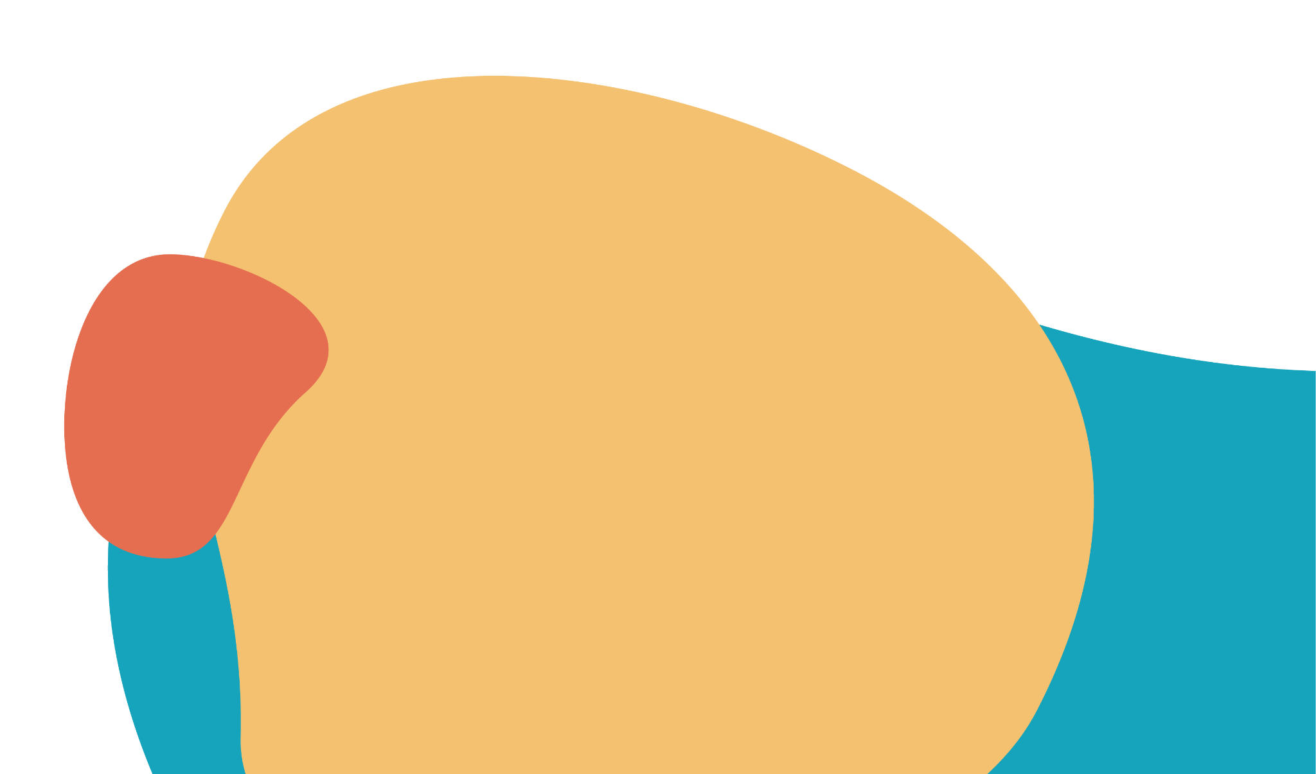

|  |
| --- |
| 4 Navigation Menus & Breadcrumbs Templates |
|  |

## Example #1



### The HTML

<div class="container">

<nav>

<ul class="bar">

<li><a href="#">Home</a></li>

<li><a href="#">About</a></li>

<li><a href="#" class="active">Contact</a></li>

<li><a href="#">Careers</a></li>

</ul>

</nav>

</div>

### The CSS

.bar {

background-color: rgb(245, 193, 97);

width: 100%;

height: 40px;

display: flex;

list-style: none;

padding: 0;

}

.bar li {

height: 100%;

width: 100px;

border-right: 1px solid rgb(235, 177, 69);

}

.bar li a {

color: black;

width: 100%;

height: 100%;

display: flex;

align-items: center;

justify-content: center;

text-decoration: none;

}

.bar li a:hover {

background-color: rgb(235, 177, 69);

}

.bar li a.active {

background-color: rgb(165, 113, 16);

color: white;

}

# 

## Example #2

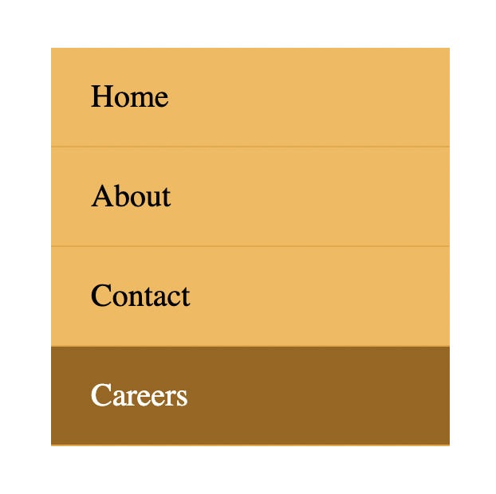

### The HTML

<div class="container">

<nav>

<ul class="bar">

<li><a href="#">Home</a></li>

<li><a href="#">About</a></li>

<li><a href="#">Contact</a></li>

<li><a href="#" class="active">Careers</a></li>

</ul>

</nav>

</div>

### The CSS

.bar {

background-color: rgb(245, 193, 97);

max-width: 200px;

width: 100%;

list-style: none;

padding: 0;

}

.bar li {

height: 100%;

width: 100%;

height: 50px;

border-bottom: 1px solid rgb(235, 177, 69);

}

.bar li a {

padding-left: 20px;

text-align: left;

color: black;

max-width: 100%;

height: 100%;

display: flex;

align-items: center;

text-decoration: none;

}

.bar li a:hover {

background-color: rgb(235, 177, 69);

}

.bar li a.active {

background-color: rgb(165, 113, 16);

color: white;

}

# 

## Example #3

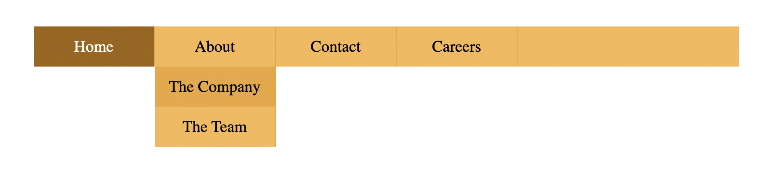

### The HTML

<div class="container">

<nav>

<ul class="bar">

<li><a href="#" class="active">Home</a></li>

<li class="has-dropdown">

<a href="#">About</a>

<ul class="dropdown">

<li><a href="#">The Company</a></li>

<li><a href="#">The Team</a></li>

</ul>

</li>

<li class="has-dropdown">

<a href="#">Contact</a>

<ul class="dropdown">

<li><a href="#">Email</a></li>

<li><a href="#">Phone</a></li>

</ul>

</li>

<li><a href="#">Careers</a></li>

</ul>

</nav>

</div>

### 

### The CSS

* {

box-sizing: border-box;

}

.bar {

background-color: rgb(245, 193, 97);

width: 100%;

height: 40px;

display: flex;

list-style: none;

padding: 0;

}

.bar li {

height: 100%;

width: 120px;

border-right: 1px solid rgb(235, 177, 69);

}

.bar li a {

color: black;

width: 100%;

height: 100%;

display: flex;

align-items: center;

justify-content: center;

text-decoration: none;

}

.bar .has-dropdown ul li a{

padding: 12px 0;

}

.bar li a:hover {

background-color: rgb(235, 177, 69);

}

.bar li a.active {

background-color: rgb(165, 113, 16);

color: white;

}

.dropdown {

background-color: rgb(245, 193, 97);

padding: 0;

list-style: none;

display: none;

}

.bar li.has-dropdown:hover .dropdown {

display: block;

}

# 

## Example #4



### The HTML

<div class="container">

<ul class="breadcrumb">

<li><a href="#" class="active">Home</a></li>

<li><span>></span></li>

<li><a href="#">Products</a></li>

<li><span>></span></li>

<li><a href="#">Computers</a></li>

<li><span>></span></li>

<li><a href="#" class="unique">Laptops</a></li>

</ul>

</div>

### 

### The CSS

.breadcrumb {

list-style: none;

padding: 0;

display: flex;

font-size: 20px;

justify-content: space-around;

max-width: 450px;

}

.breadcrumb a {

text-decoration: none;

color: rgb(110, 110, 110);

font-weight: bold;

}

.breadcrumb li span{

color: gray;

}

.breadcrumb li a {

color: orange;

transition: color 300ms;

}

.breadcrumb li .unique {

color: #000;

}

.breadcrumb li a:hover {

color: rgb(176, 115, 0);

}



|  |
| --- |
| 5 Button  Transition Templates |
|  |

## Example #1



### The HTML

<button class="first">Hover over me</button>

## The CSS

.first {

padding: 10px;

font-size: 20px;

background-color: black;

color: white;

border: none;

cursor: pointer;

box-shadow: 0 0 0 #ccc;

transition: box-shadow 300ms, color 300ms;

}

.first:hover {

color: yellow;

box-shadow: 10px 10px 0 rgb(219, 219, 219);

}

## Example #2

 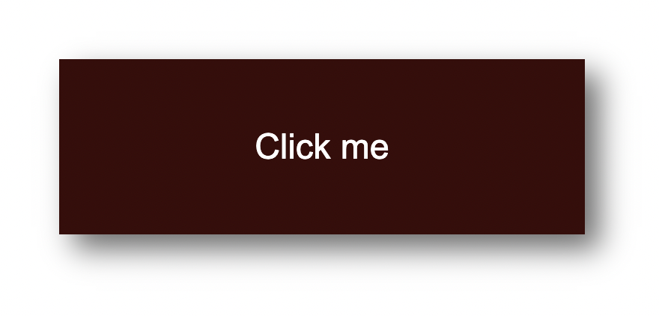

### The HTML

<button class="second">Click me</button>

### The CSS

.second {

width: 180px;

height: 60px;

display: flex;

align-items: center;

justify-content: center;

font-size: 20px;

background-color: rgb(85, 16, 16);

color: white;

border: none;

cursor: pointer;

transition: transform 150ms,

font-size 150ms, color 150ms;

}

.second:active {

background-color: rgb(63, 5, 5);

font-size: 12px;

transform: scale(1.3);

box-shadow: 5px 5px 10px rgb(119, 119, 119);

## Example #3

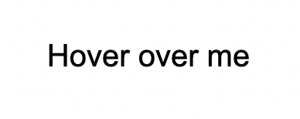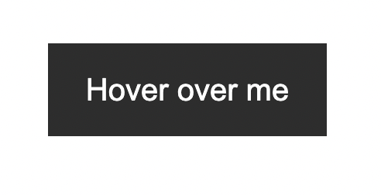

## The HTML

<button class="third">Hover over me</button>

### The CSS

.third {

border: none;

background: none;

width: 120px;

height: 40px;

cursor: pointer;

position: relative;

color: black;

transition: color 500ms;

overflow: hidden;

}

.third::after {

content: "";

background-color: #333;

color: white;

position: absolute;

left: 0;

bottom: -40px;

width: 100%;

height: 100%;

transition: bottom 500ms;

z-index: -1;

}

.third:hover {

color: white;

}

.third:hover::after {

bottom: 0;

}

## Example #4

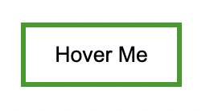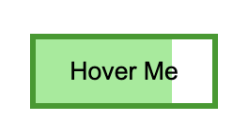

### The HTML

<button class="fourth">

Hover Me

</button>

### The CSS

.fourth {

cursor: pointer;

border: 3px solid rgb(25, 155, 25);

width: 100px;

height: 40px;

display: flex;

justify-content: center;

align-items: center;

background-color: white;

background: none;

position: relative;

}

.fourth::before {

content: "";

position: absolute;

top: 0;

left: 0;

width: 0;

height: 100%;

background-color: rgb(148, 236, 148);

z-index: -1;

transition: width 300ms;

}

.fourth:hover::before {

width: 100%;

}

## Example #5

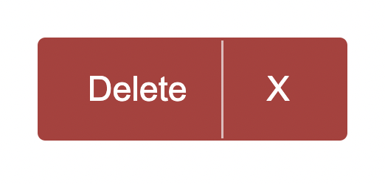

### The HTML

<button class="fifth">

<span class="delete center">Delete</span>

<span class="icon center">X</span>

</button>

### The CSS

.center {

display: flex;

justify-content: center;

align-items: center;

}

.fifth {

width: 120px;

height: 40px;

background-color: rgb(178, 57, 57);

border: none;

color: white;

border-radius: 3px;

cursor: pointer;

display: flex;

}

.delete {

width: 90px;

height: 100%;

opacity: 1;

transition: width 300ms, opacity 300ms;

}

.icon {

padding: 0 10px;

width: 30px;

border-left: 1px solid rgb(226, 187, 187);

height: 100%;

transition: width 300ms,

border-left-color 300ms;

}

.fifth:hover .delete {

width: 0px;

opacity: 0;

}

.fifth:hover .icon {

width: 100%;

border-left-color: transparent;

font-weight: bold;

}

|  |
| --- |
| 3 Web Form & Search Bar Templates |
|  |

## Template #1

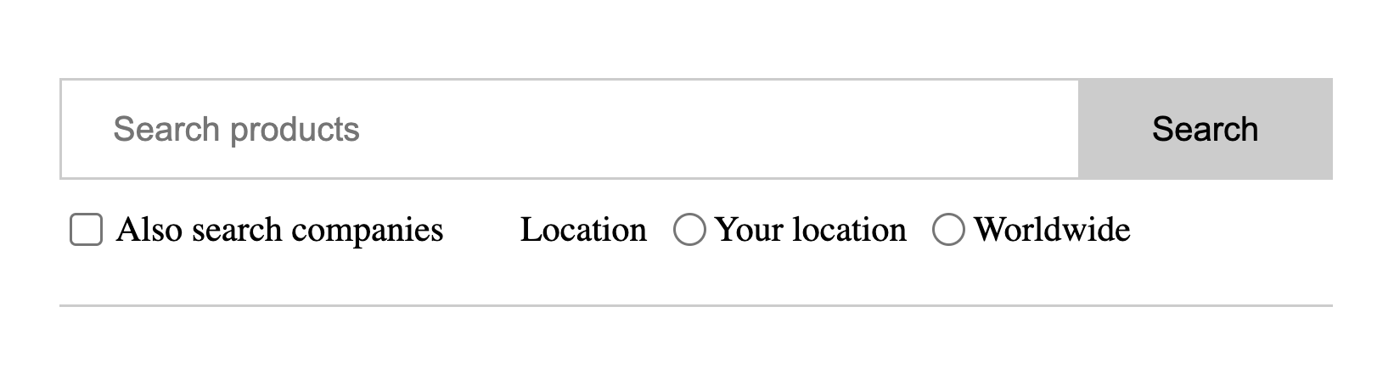

### The HTML

<form>

<div class="search">

<input type="text" placeholder="Search products" />

<button type="submit">Search</button>

</div>

<div class="align-center bottom">

<div class="checkbox-block">

<input

type="checkbox"

name="companies_included"

id="companies_included"

/>

<label for="companies_included"

>Also search companies

</label>

</div>

<div class="inline-flex radio-block">

<span>Location</span>

<div class="inline-flex align-center">

<input

type="radio"

name="location"

value="Your location"

id="your_location"

/>

<label for="your_location"> Your location </label>

</div>

<div class="inline-flex align-center">

<input

type="radio"

name="location"

value="Worldwide"

id="worldwide"

/>

<label for="worldwide"> Worldwide </label>

</div>

</div>

</div>

</form>

### 

### The CSS

.align-center {

display: flex;

align-items: center;

}

.inline-flex {

display: inline-flex;

}

form {

padding: 20px 0;

max-width: 500px;

border-bottom: 1px solid #ccc;

}

.search {

display: flex;

outline: 1px solid #cccccc;

}

.search > input {

flex-grow: 1;

border: 0;

padding: 0.5rem 1rem;

font-size: 1rem;

}

.search > input:focus {

outline: none;

}

.search > button {

padding: 0.8rem 2rem;

border: 0;

cursor: pointer;

font-size: 1rem;

background: #cccccc;

}

.bottom {

margin-top: 10px;

font-size: 14px;

}

.checkbox-block {

display: flex;

align-items: center;

margin-right: 30px;

}

.checkbox-block input {

margin-right: 5px;

cursor: pointer;

}

.radio-block input {

margin: 0 3px 0 10px;

}

## Template #2

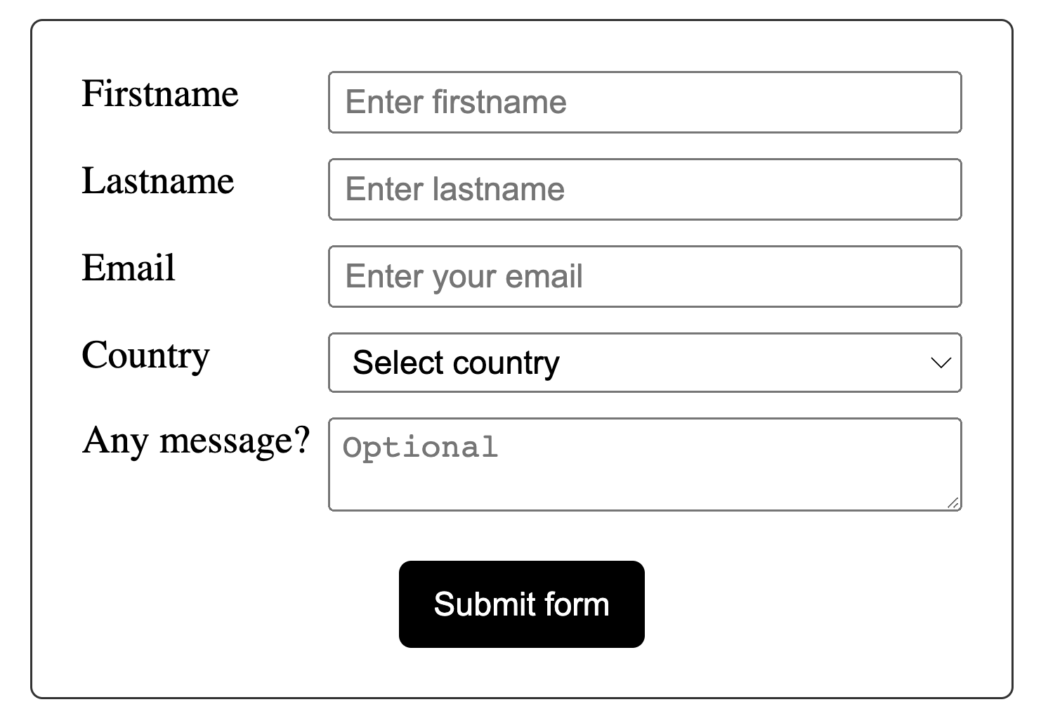

### The HTML

<form>

<div class="input-group">

<label for="fname">Firstname</label>

<input

id="fname"

name="fname"

placeholder="Enter firstname"

required="required"

/>

</div>

<div class="input-group">

<label for="lname">Lastname</label>

<input

id="lname"

name="lname"

placeholder="Enter lastname"

required="required"

/>

</div>

<div class="input-group">

<label for="email">Email</label>

<input

id="email"

type="email"

name="email"

placeholder="Enter your email"

/>

</div>

<div class="input-group">

<label>Country</label>

<select name="country" id="country" required="required">

<option value="" selected="selected">Select country</option>

<option value="Afghanistan">Afghanistan</option>

<option value="Albania">Albania</option>

<option value="Algeria">Algeria</option>

<option value="American Samoa">American Samoa</option>

<option value="Andorra">Andorra</option>

<option value="Angola">Angola</option>

<option value="Anguilla">Anguilla</option>

<option value="Antarctica">Antarctica</option>

</select>

</div>

<div class="input-group">

<label for="message">Any message?</label>

<textarea

id="message"

name="message"

placeholder="Optional"

></textarea>

</div>

<div class="submit-group">

<button type="submit">Submit form</button>

</div>

</form>

### The CSS

* {

box-sizing: border-box;

}

body {

margin: 30px;

}

form {

border: 1px solid #333;

padding: 20px;

max-width: 400px;

margin: 0 auto;

border-radius: 5px;

}

.input-group {

display: flex;

margin-bottom: 10px;

}

label {

width: 100px;

}

input,

select,

textarea {

flex: 1;

padding: 3px 5px;

}

.submit-group {

display: flex;

align-items: center;

justify-content: center;

margin-top: 20px;

}

button {

width: 100px;

margin: 0 auto;

background-color: black;

color: white;

border: none;

padding: 10px;

cursor: pointer;

border-radius: 5px;

}

## Template #2

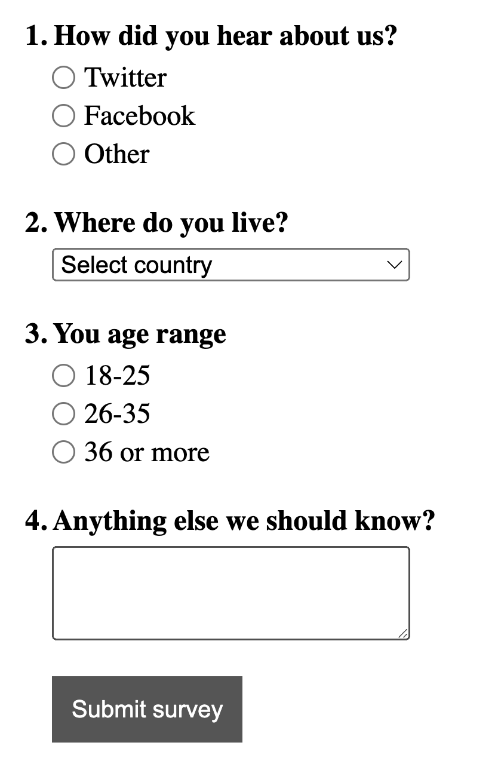

### The HTML

<form>

<div>

<span class="question">1. How did you hear about us?</span>

<div class="radio-group">

<div class="radio-item">

<input type="radio" name="hear_about_us" id="twitter" />

<label for="twitter">Twitter</label>

</div>

<div class="radio-item">

<input type="radio" name="hear_about_us" id="facebook" />

<label for="facebook">Facebook</label>

</div>

<div class="radio-item">

<input type="radio" name="hear_about_us" id="other" />

<label for="other">Other</label>

</div>

</div>

</div>

<div>

<span class="question">2. Where do you live?</span>

<select name="country" id="country" required="required">

<option value="" selected="selected">Select country</option>

<option value="Afghanistan">Afghanistan</option>

<option value="Albania">Albania</option>

<option value="Algeria">Algeria</option>

<option value="American Samoa">American Samoa</option>

<option value="Andorra">Andorra</option>

<option value="Angola">Angola</option>

<option value="Anguilla">Anguilla</option>

<option value="Antarctica">Antarctica</option>

</select>

</div>

<div>

<span class="question">3. You age range</span>

<div class="radio-group">

<div class="radio-item">

<input type="radio" name="age_range" id="lower" />

<label for="lower">18-25</label>

</div>

<div class="radio-item">

<input type="radio" name="age_range" id="middle" />

<label for="middle">26-35</label>

</div>

<div class="radio-item">

<input type="radio" name="age_range" id="higher" />

<label for="higher">36 or more</label>

</div>

</div>

</div>

<div>

<span class="question">4. Anything else we should know? </span>

<textarea name="message"></textarea>

</div>

<div>

<button class="submit-btn">Submit survey</button>

</div>

</form>

### The CSS

* {

box-sizing: border-box;

}

body {

margin: 30px;

}

form {

max-width: 400px;

}

form > div {

margin-bottom: 20px;

}

.question {

font-weight: bold;

display: block;

margin-bottom: 5px;

}

.radio-group,

select,

textarea {

margin-left: 15px;

width: 200px;

}

textarea {

padding: 10px;

}

.radio-item {

display: flex;

align-items: center;

margin-bottom: 3px;

}

.radio-item label {

margin-left: 5px;

}

.radio-item input {

margin: 0;

}

.submit-btn {

margin-left: 15px;

background-color: #555;

border: 1px solid #555;

color: white;

padding: 10px;

cursor: pointer;

}



|  |
| --- |
| 1 Lightbox Modal Element Template |
|  |

## Template

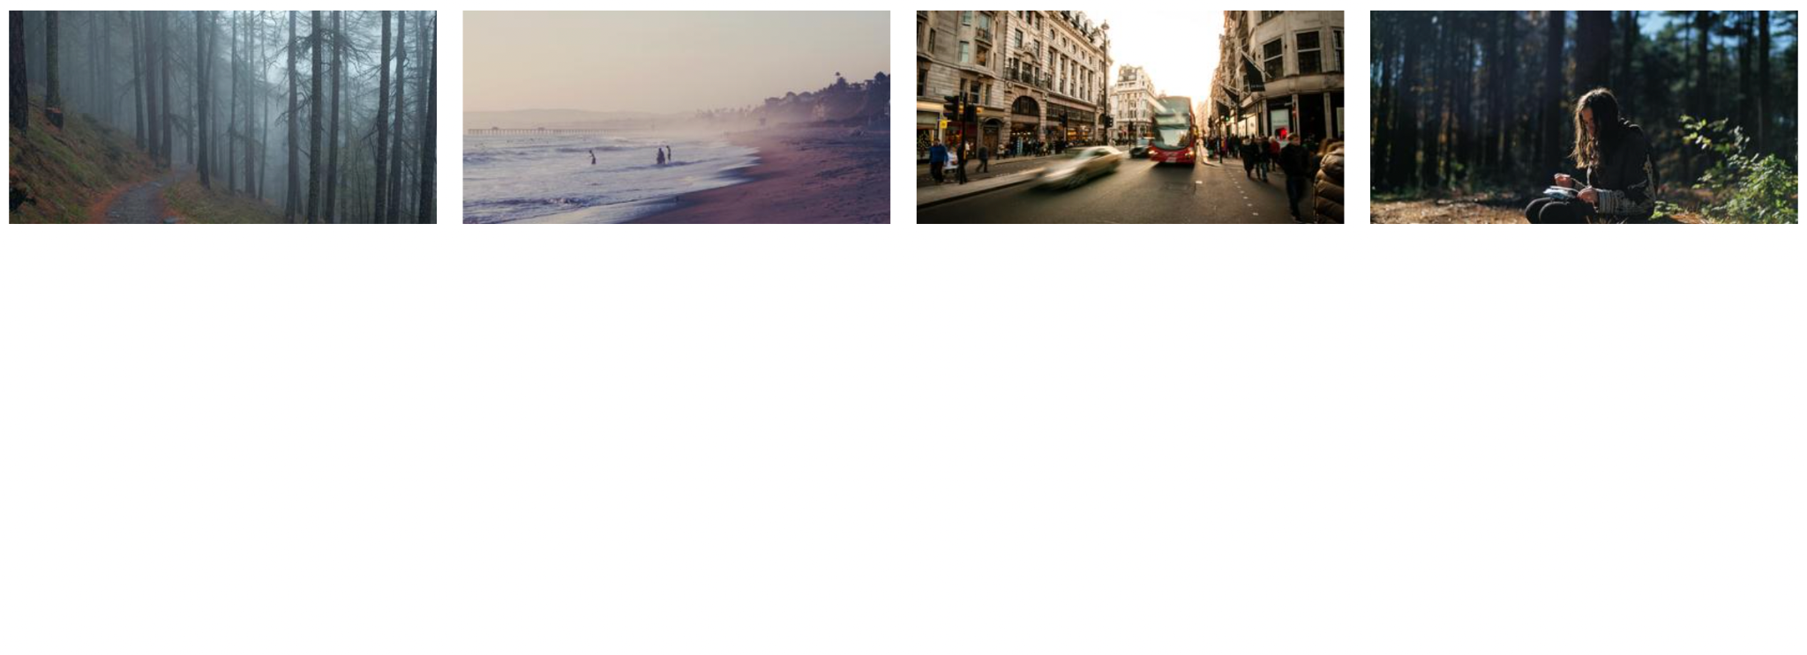

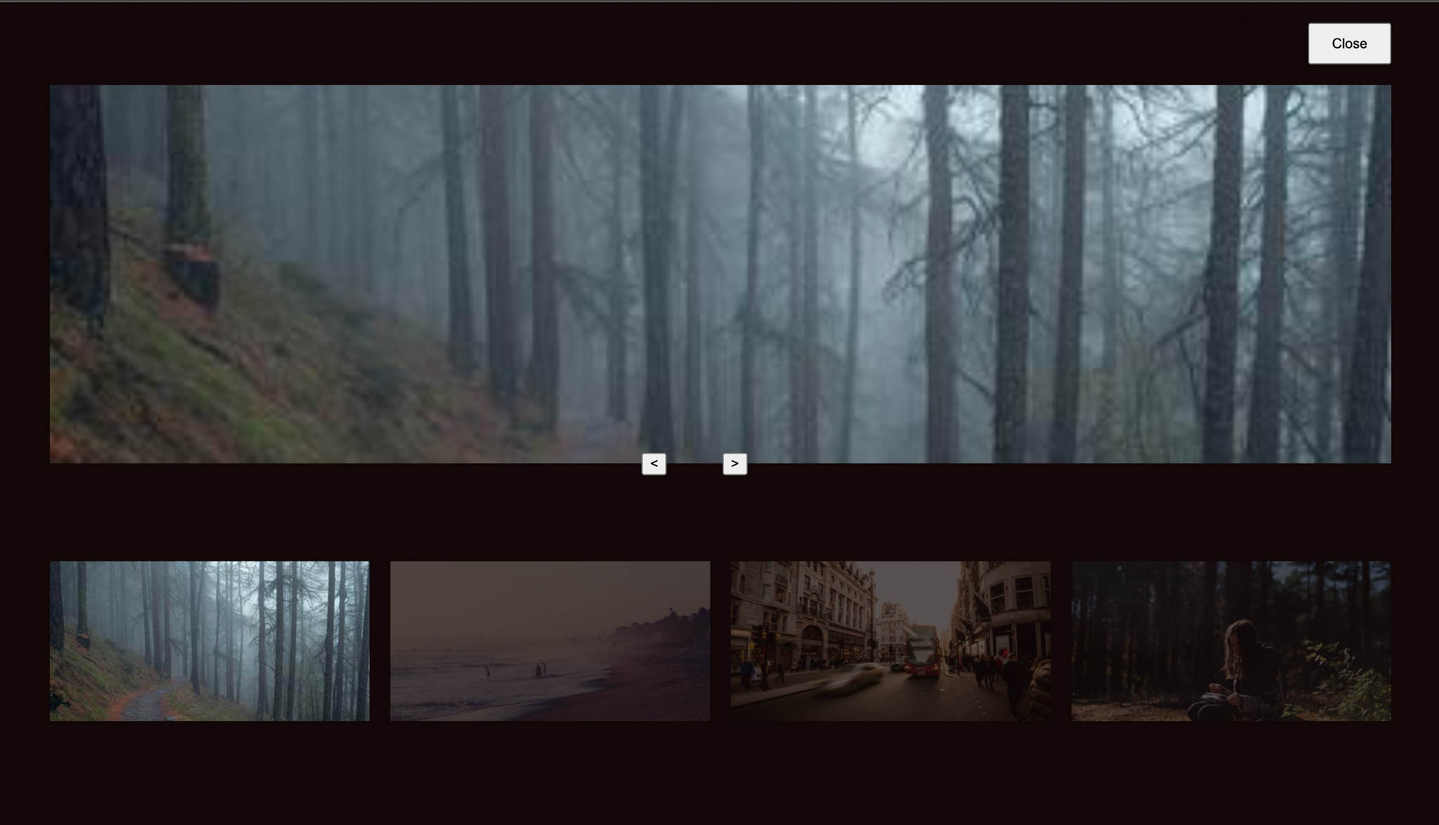

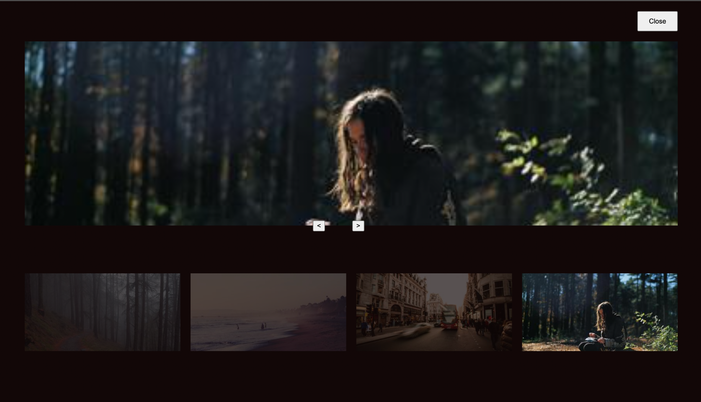

### The HTML

<div class="images">

<img onclick="openModal(0)" id="image0" />

<img onclick="openModal(1)" id="image1" />

<img onclick="openModal(2)" id="image2" />

<img onclick="openModal(3)" id="image3" />

</div>

<div id="lightbox" class="lightbox">

<button onclick="closeModal()" class="close-btn">

Close

</button>

<div class="image-preview">

<img id="preview-image" />

</div>

<div class="control-btns">

<button onclick="control(-1)" class="control-left">

&lt;

</button>

<button onclick="control(1)" class="control-left">

&gt;

</button>

</div>

<div id="modal-images-block" class="lightbox__images">

<img onclick="openModal(0)" id="l-image0" />

<img onclick="openModal(1)" id="l-image1" />

<img onclick="openModal(2)" id="l-image2" />

<img onclick="openModal(3)" id="l-image3" />

</div>

</div>

### The CSS

* {

box-sizing: border-box;

}

.images {

display: grid;

grid-template-columns: repeat(4, 1fr);

grid-gap: 20px;

}

.images img {

width: 100%;

height: 100%;

cursor: pointer;

}

.lightbox {

position: absolute;

left: 0;

top: 0;

padding: 0 50px 30px;

width: 100%;

height: 100vh;

background-color: rgb(18, 7, 7);

display: none;

flex-direction: column;

}

.lightbox.visible {

display: flex;

}

.lightbox .close-btn {

width: 80px;

align-self: flex-end;

height: 40px;

margin: 20px 0;

}

.lightbox .image-preview {

width: 100%;

margin: 0 auto;

flex: 1;

height: 100%;

overflow: hidden;

display: flex;

flex-direction: column;

align-items: center;

}

.image-preview img {

width: 100%;

height: 100%;

object-fit: cover;

}

.control-btns {

position: relative;

top: -10px;

margin: 0 auto;

}

.control-btns button {

cursor: pointer;

}

.control-left {

margin-right: 50px;

}

.lightbox__images {

height: 300px;

display: grid;

grid-template-columns: repeat(4, 1fr);

grid-gap: 20px;

align-items: center;

}

.lightbox__images img {

width: 100%;

opacity: 0.3;

cursor: pointer;

}

.lightbox__images img.active {

width: 100%;

opacity: 1;

}

### The JavaScript

const IMAGE0 =

"https://i.picsum.photos/id/229/400/200.jpg?hmac=ULnwo8IFtjR3PshWPNEvFWNU8Xwl_OIeUtVmZIQanhU"

const IMAGE1 =

"https://i.picsum.photos/id/154/400/200.jpg?hmac=uhKcJIPoFcq2xMC16yvZAwA8sTeIbThUr-Njq0DkhSU"

const IMAGE2 =

"https://i.picsum.photos/id/690/400/200.jpg?hmac=kOkDXkZEUaSUQviVm67apRu5EPMD_L0rHfKVt32iogQ"

const IMAGE3 =

"https://i.picsum.photos/id/633/400/200.jpg?hmac=-axbA3Zg3r_xPYOy7OdaIb5yTFDBKubd9LYJrnwpHeU"

const images = [IMAGE0, IMAGE1, IMAGE2, IMAGE3]

const image0 = document.getElementById("image0")

const image1 = document.getElementById("image1")

const image2 = document.getElementById("image2")

const image3 = document.getElementById("image3")

const lightbox = document.getElementById("lightbox")

const previewImg = document.getElementById("preview-image")

const modalImagesBlock = document.getElementById(

"modal-images-block"

)

image0.src = IMAGE0

image1.src = IMAGE1

image2.src = IMAGE2

image3.src = IMAGE3

let activeId = null

previewImg.src = images[0]

const modalImagesElements =

modalImagesBlock.getElementsByTagName("img")

const modalImages = Object.values(modalImagesElements)

modalImages.forEach((imageElement, i) => {

console.log(imageElement)

imageElement.src = images[i]

})

function openModal(imgId) {

if (activeId !== null) {

modalImages[activeId].classList.remove("active")

}

activeId = imgId

lightbox.classList.add("visible")

previewImg.src = images[imgId]

modalImages[imgId].classList.add("active")

}

function closeModal() {

lightbox.classList.remove("visible")

}

function control(direction) {

const prevId = activeId

if (direction === 1) {

// next

activeId =

activeId + 1 > images.length - 1

? // then go to the beginning

(activeId = 0)

: (activeId = activeId + 1)

} else {

// previous

activeId =

activeId - 1 < 0

? // then go to the end

(activeId = images.length - 1)

: activeId - 1

}

previewImg.src = images[activeId]

modalImages[activeId].classList.add("active")

modalImages[prevId].classList.remove("active")

}



|  |
| --- |
| 4 Tooltip Templates |
|  |

## Example #1

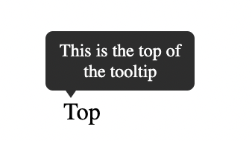

### The HTML

<div class="tooltip">

<span>Top</span>

<div class="tooltip-text">This is the top of the tooltip</div>

</div>

### The CSS

body {

margin: 60px;

}

.tooltip {

position: relative;

display: inline-block;

}

.tooltip-text {

padding: 6px;

background-color: #333;

color: white;

font-size: 12px;

position: absolute;

border-radius: 5px;

width: 100px;

text-align: center;

display: inline-block;

top: -45px;

left: -12px;

visibility: hidden;

}

.tooltip-text::after {

content: "";

position: absolute;

left: 10px;

bottom: -5px;

width: 0;

height: 0;

border-left: 7px solid transparent;

border-right: 7px solid transparent;

border-top: 10px solid #333;

}

.tooltip:hover .tooltip-text {

visibility: visible;

}

# 

## Example #2

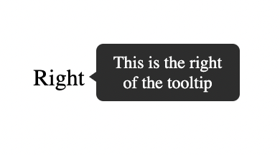

### The HTML

<div class="tooltip">

<span>Right</span>

<div class="tooltip-text">This is the right of the tooltip</div>

</div>

### 

### The CSS

.tooltip {

position: relative;

display: inline-block;

}

.tooltip-text {

padding: 6px;

background-color: #333;

color: white;

font-size: 12px;

position: absolute;

border-radius: 5px;

width: 100px;

text-align: center;

right: -120px;

bottom: -7px;

visibility: hidden;

}

.tooltip-text::after {

content: "";

position: absolute;

left: -5px;

bottom: 10px;

width: 0;

height: 0;

border-top: 7px solid transparent;

border-bottom: 7px solid transparent;

border-right: 10px solid #333;

}

.tooltip:hover .tooltip-text {

visibility: visible;

}

# 

## Example #3

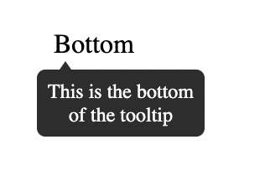

### The HTML

<div class="tooltip">

<span>Bottom</span>

<div class="tooltip-text"> This is the bottom of the tooltip </div>

</div>

### The CSS

.tooltip {

position: relative;

display: inline-block;

}

.tooltip-text {

padding: 6px;

background-color: #333;

color: white;

font-size: 12px;

position: absolute;

border-radius: 5px;

width: 100px;

text-align: center;

display: inline-block;

bottom: -46px;

left: -10px;

visibility: hidden;

}

.tooltip-text::after {

content: "";

position: absolute;

left: 10px;

top: -5px;

width: 0;

height: 0;

border-left: 7px solid transparent;

border-right: 7px solid transparent;

border-bottom: 10px solid #333;

}

.tooltip:hover .tooltip-text {

visibility: visible;

}

# 

## Example #4

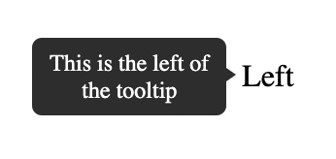

### The HTML

<div class="tooltip">

<span>Left</span>

<div class="tooltip-text">This is the left of the tooltip</div>

</div>

### The CSS

body {

margin: 60px 130px;

}

.tooltip {

position: relative;

display: inline-block;

}

.tooltip-text {

padding: 6px;

background-color: #333;

color: white;

font-size: 12px;

position: absolute;

border-radius: 5px;

width: 100px;

text-align: center;

left: -120px;

bottom: -11px;

visibility: hidden;

}

.tooltip-text::after {

content: "";

position: absolute;

right: -5px;

top: 12px;

width: 0;

height: 0;

border-top: 7px solid transparent;

border-bottom: 7px solid transparent;

border-left: 10px solid #333;

}

.tooltip:hover .tooltip-text {

visibility: visible;

}



|  |
| --- |
| 2 Progress Bar Templates |
|  |

## Example #1

## 

### The HTML

<progress class="first" value="50" max="100"></progress>

### The CSS

.first {

border-radius: 0;

border: 2px solid purple;

height: 30px;

width: 250px;

}

.first::-webkit-progress-bar {

background-color: white;

}

.first::-webkit-progress-value {

background-color: purple;

}

# 

## Example #2

### The HTML

<progress class="second" value="40" max="100"></progress>

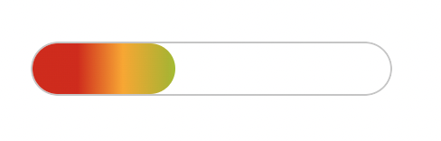

<progress class="second" value="80" max="100"></progress>

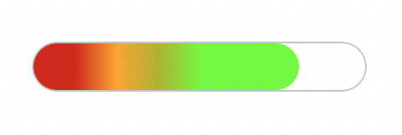

### The CSS

.second {

overflow: hidden;

border-radius: 15px;

height: 30px;

width: 200px;

}

.second::-webkit-progress-bar {

border-radius: 15px;

background-color: white;

border: 1px solid #ccc;

}

.second::-webkit-progress-value {

background-image: linear-gradient(

90deg,

hsl(0deg 91% 46%) 25px,

hsl(41deg 100% 50%) 50px,

hsl(63deg 100% 37%) 75px,

rgb(85, 255, 0) 100px

);

border-radius: 15px;

}



|  |
| --- |
| 2 CSS Accordion Templates |
|  |

## Example #1: Accordion Using Only CSS and HTML

### The HTML

<!DOCTYPE html>

<html lang="en">

<head>

<title>Document</title>

<link rel="stylesheet" href="style.css" />

</head>

<body>

<div class="container">

<h1>CSS Accordion</h1>

<div class="accordion">

<div class="tab">

<input type="checkbox" id="tab1" />

<label class="tab-label" for="tab1">Lorem ipsum 1</label>

<div class="tab-content">

Lorem ipsum dolor sit, amet consectetur adipisicing elit. Doloremque

perferendis eligendi fugit quaerat consequatur fuga pariatur

ratione, enim mollitia aut! Nobis maxime voluptas harum labore quos,

tempore itaque quas excepturi.

</div>

</div>

<div class="tab">

<input type="checkbox" id="tab2" />

<label class="tab-label" for="tab2">Lorem ipsum 2</label>

<div class="tab-content">

Lorem ipsum dolor sit, amet consectetur adipisicing elit. Doloremque

perferendis eligendi fugit quaerat consequatur fuga pariatur

ratione, enim mollitia aut! Nobis maxime voluptas harum labore quos,

tempore itaque quas excepturi.

</div>

</div>

<div class="tab">

<input type="checkbox" id="tab3" />

<label class="tab-label" for="tab3">Lorem ipsum 3</label>

<div class="tab-content">

Lorem ipsum dolor sit, amet consectetur adipisicing elit. Doloremque

perferendis eligendi fugit quaerat consequatur fuga pariatur

ratione, enim mollitia aut! Nobis maxime voluptas harum labore quos,

tempore itaque quas excepturi.

</div>

</div>

</div>

</div>

</body>

</html>

### The CSS

@import "https://fonts.googleapis.com/css?family=Montserrat:400,700|Raleway:300,400";

body {

color: #2c3e50;

background: #ecf0f1;

width: 100vw;

padding: 0 1em 1em;

font-family: "Raleway", sans-serif;

}

h1 {

margin: 0;

line-height: 2;

text-align: center;

}

input {

position: absolute;

opacity: 0;

z-index: -1;

}

/* Accordion styles */

.accordion {

border-radius: 8px;

width: 70vw;

margin: 5rem auto 0;

overflow: hidden;

padding: 2rem 2.5rem;

background-color: white;

box-shadow: 0 4px 4px 2px rgba(0, 0, 0, 0.15);

}

.tab {

width: 100%;

color: #1a252f;

overflow: hidden;

margin: 1rem 0;

}

.tab-label {

display: flex;

justify-content: space-between;

padding: 1rem;

background: white;

font-weight: bold;

cursor: pointer;

}

.tab-label:hover {

background: #dce7ea;

}

.tab-label::after {

content: "❯";

width: 1em;

height: 1em;

text-align: center;

transition: all 0.35s;

}

.tab-content {

max-height: 0;

padding: 0 1em;

line-height: 2rem;

color: #1a252f;

background: white;

transition: all 0.35s;

}

.tab-close {

display: flex;

justify-content: flex-end;

padding: 1em;

font-size: 0.75em;

background: #2c3e50;

cursor: pointer;

}

.tab-close:hover {

background: #dce7ea;

}

input:checked + .tab-label {

background: #dce7ea;

}

input:checked + .tab-label::after {

transform: rotate(90deg);

}

input:checked ~ .tab-content {

max-height: 100vh;

padding: 1rem;

}

## Example #2: Accordion Using CSS and HTML and JavaScript

### The HTML

<!DOCTYPE html>

<html lang="en">

<head>

<title>Document</title>

<link rel="stylesheet" href="style.css" />

</head>

<body>

<div class="container">

<h1>CSS Accordion With Javascript</h1>

<div class="accordion">

<div class="tab">

<input type="checkbox" id="tab1" />

<label class="tab-label" for="tab1">Lorem ipsum 1</label>

<div class="tab-content">

Lorem ipsum dolor sit, amet consectetur adipisicing elit. Doloremque

perferendis eligendi fugit quaerat consequatur fuga pariatur

ratione, enim mollitia aut! Nobis maxime voluptas harum labore quos,

tempore itaque quas excepturi.

</div>

</div>

<div class="tab">

<input type="checkbox" id="tab2" />

<label class="tab-label" for="tab2">Lorem ipsum 2</label>

<div class="tab-content">

Lorem ipsum dolor sit, amet consectetur adipisicing elit. Doloremque

perferendis eligendi fugit quaerat consequatur fuga pariatur

ratione, enim mollitia aut! Nobis maxime voluptas harum labore quos,

tempore itaque quas excepturi.

</div>

</div>

<div class="tab">

<input type="checkbox" id="tab3" />

<label class="tab-label" for="tab3">Lorem ipsum 3</label>

<div class="tab-content">

Lorem ipsum dolor sit, amet consectetur adipisicing elit. Doloremque

perferendis eligendi fugit quaerat consequatur fuga pariatur

ratione, enim mollitia aut! Nobis maxime voluptas harum labore quos,

tempore itaque quas excepturi.

</div>

</div>

</div>

</div>

<script src="index.js"></script>

</body>

</html>

### The CSS

@import "https://fonts.googleapis.com/css?family=Montserrat:400,700|Raleway:300,400";

body {

color: #2c3e50;

background: #ecf0f1;

width: 100vw;

padding: 0 1em 1em;

font-family: "Raleway", sans-serif;

}

h1 {

margin: 0;

line-height: 2;

text-align: center;

color: #ff6873;

}

input {

position: absolute;

opacity: 0;

z-index: -1;

}

/* Accordion styles */

.accordion {

border-radius: 8px;

width: 70vw;

margin: 5rem auto 0;

overflow: hidden;

padding: 2rem 2.5rem;

background-color: white;

box-shadow: 0 4px 4px 2px rgba(0, 0, 0, 0.15);

}

.tab {

width: 100%;

color: #1a252f;

overflow: hidden;

margin: 1.4rem 0;

}

.tab-label {

display: flex;

justify-content: space-between;

padding: 1rem;

font-size: 1.2rem;

color: #ff6873;

font-weight: bold;

cursor: pointer;

}

.tab-label::after {

content: "❯";

width: 1em;

height: 1em;

color: #ff6873;

text-align: center;

transition: all 0.35s;

}

.tab-content {

max-height: 0;

padding: 0 1em;

line-height: 2rem;

color: #1a252f;

background: white;

transition: all 0.35s;

}

.tab-close {

display: flex;

justify-content: flex-end;

padding: 1em;

font-size: 0.75em;

background: #2c3e50;

cursor: pointer;

}

.open-tab .tab-label::after {

transform: rotate(90deg);

}

.open-tab .tab-content {

max-height: 100vh;

padding: 1rem;

}

### The JavaScript

const accordions = document.getElementsByClassName("tab");

for (const accordion of accordions) {

accordion.addEventListener("click", function (e) {

e.preventDefault();

accordion.classList.toggle("open-tab");

});

}



|  |
| --- |
| 4 CSS Effects Templates |
|  |

## Template #1: Opacity

### The HTML

<!DOCTYPE html>

<html lang="en">

<head>

<link rel="stylesheet" href="style.css" />

</head>

<body>

<div class="container">

<div class="box">

<img src="./girl-with-guitar.jpeg" alt="img" />  
 <img

src="./girl-with-guitar.jpeg"

alt="img"

class="translucent"

/>

</div>

</div>

</body>

</html>

### The CSS

*,

*::after,

*::before {

margin: 0;

padding: 0;

box-sizing: border-box;

}

.container {

display: flex;

flex-flow: column nowrap;

justify-content: space-around;

align-items: center;

min-height: 100vh;

width: 100vw;

background: #c8c7c7;

font-family: "Roboto", sans-serif;

}

.box {

width: 90%;

height: 60%;

display: flex;

flex-flow: row nowrap;

justify-content: space-around;

align-items: center;

margin: 1rem 0;

}

.box img {

width: 48%;

}

.translucent {

filter: opacity(35%);

}

# 

## Template #2: Grayscale

### The HTML

<!DOCTYPE html>

<html lang="en">

<head>

<link rel="stylesheet" href="style.css" />

</head>

<body>

<div class="container">

<div class="box">

<img src="./girl-with-guitar.jpeg" alt="img" />  
 <img

src="./girl-with-guitar.jpeg"

alt="img"

class="black-white"

/>

</div>

</div>

</body>

</html>

### The CSS

*,

*::after,

*::before {

margin: 0;

padding: 0;

box-sizing: border-box;

}

.container {

display: flex;

flex-flow: column nowrap;

justify-content: space-around;

align-items: center;

min-height: 100vh;

width: 100vw;

background: #c8c7c7;

font-family: "Roboto", sans-serif;

}

.box {

width: 90%;

height: 60%;

display: flex;

flex-flow: row nowrap;

justify-content: space-around;

align-items: center;

margin: 1rem 0;

}

.box img {

width: 48%;

}

.black-white {

filter: grayscale(100%);

}

# 

## Template #3: Sepia

### The HTML

<!DOCTYPE html>

<html lang="en">

<head>

<link rel="stylesheet" href="style.css" />

</head>

<body>

<div class="container">

<div class="box">

<img src="./girl-with-guitar.jpeg" alt="img" />  
 <img

src="./girl-with-guitar.jpeg"

alt="img"

class="nineties-effect"

/>

</div>

</div>

</body>

</html>

### The CSS

*,

*::after,

*::before {

margin: 0;

padding: 0;

box-sizing: border-box;

}

.container {

display: flex;

flex-flow: column nowrap;

justify-content: space-around;

align-items: center;

min-height: 100vh;

width: 100vw;

background: #c8c7c7;

font-family: "Roboto", sans-serif;

}

.box {

width: 90%;

height: 60%;

display: flex;

flex-flow: row nowrap;

justify-content: space-around;

align-items: center;

margin: 1rem 0;

}

.box img {

width: 48%;

}

.nineties-effect {

filter: sepia(100%);

}

# 

## Template #4: Hover

### The HTML

<!DOCTYPE html>

<html lang="en">

<head>

<link rel="stylesheet" href="style.css" />

</head>

<body>

<div class="container">

<div class="box">

<img src="./girl-with-guitar.jpeg" alt="img" />  
 <img

src="./girl-with-guitar.jpeg"

alt="img"

class="hover-effect"

/>

</div>

</div>

</body>

</html>

### The CSS

*,

*::after,

*::before {

margin: 0;

padding: 0;

box-sizing: border-box;

}

.container {

display: flex;

flex-flow: column nowrap;

justify-content: space-around;

align-items: center;

min-height: 100vh;

width: 100vw;

background: #fafafa;

/* background: #c8c7c7; */

font-family: "Roboto", sans-serif;

}

.box {

width: 90%;

height: 60%;

display: flex;

flex-flow: row nowrap;

justify-content: space-around;

align-items: center;

margin: 1rem 0;

}

.box img {

width: 48%;

}

.hover-effect:hover {

filter: grayscale(100%);

}



|  |
| --- |
| 2 CSS Tab Navigation Templates |
|  |

## Template #1: CSS Tab Navigation with Animation Effects

### The HTML

<!DOCTYPE html>

<html lang="en">

<head>

<title>Document</title>

<link rel="stylesheet" href="styles.css" />

</head>

<body>

<!-- Tabbed image gallery -->

<div class="tabbed-gallery">

<div class="btn-row">

<button class="btn active-btn">New York</button>

<button class="btn">Honolulu</button>

<button class="btn">Seoul</button>

</div>

<div id="New York" class="city">

<img src="./img/new-york.jpeg" alt="New York" class="" />

<p>New York City</p>

</div>

<div id="Honolulu" class="city hidden-city">

<img src="./img/honolulu.jpeg" alt="Honolulu" class="" />

<p>Honolulu</p>

</div>

<div id="Seoul" class="city hidden-city">

<img src="./img/seoul.jpeg" alt="Seoul" class="" />

<p>Seoul</p>

</div>

</div>

<script src="index.js"></script>

</body>

</html>

### The CSS

@import url("https://fonts.googleapis.com/css2?family=DynaPuff&display=swap");

* {

padding: 0;

margin: 0;

box-sizing: border-box;

font-family: "DynaPuff", cursive, sans-serif;

}

body {

width: 100vw;

}

.tabbed-gallery {

width: 80vw;

margin: 6rem auto 0;

}

.btn-row {

display: grid;

grid-template-columns: repeat(3, 8rem);

grid-template-rows: 3.5rem;

column-gap: 8rem;

justify-content: center;

padding: 2rem auto;

background-color: #1d1d27;

}

.btn {

padding: 4px 2px;

font-size: 1.2rem;

border: none;

outline: none;

transition: all 300ms ease;

}

.btn:hover {

cursor: pointer;

}

.active-btn {

color: #fafafa;

background-color: #4343f5;

}

.city {

width: 100%;

height: 75vh;

position: relative;

display: block;

transition: all 400ms ease;

}

.hidden-city {

display: none;

}

.city img {

width: 100%;

height: 100%;

image-rendering: optimizeQuality;

}

.city p {

position: absolute;

bottom: 15%;

left: 50%;

transform: translate(-50%);

text-align: center;

color: #fafafa;

font-size: 3.5rem;

}

### 

### The JavaScript

const buttons = document.querySelectorAll(".btn");

const cities = document.querySelectorAll(".city");

function showCity(e, index) {

//adds the hidden-city class to all image element and removes the active-btn class from all buttons

for (let i = 0; i < cities.length; i++) {

cities[i].classList.add("hidden-city");

buttons[i].classList.remove("active-btn");

}

//add the active-btn class to the clicked button

e.target.classList.add("active-btn");

// pick the right city and make it visible

cities[index].classList.remove("hidden-city");

}

buttons.forEach((button, index) => {

button.addEventListener("click", (e) => {

showCity(e, index);

});

});

## Template #2: CSS Tab Navigation with a Simple Tabbed Image Gallery

### The HTML

<!DOCTYPE html>

<html lang="en">

<head>

<title>Document</title>

<link rel="stylesheet" href="styles.css" />

</head>

<body>

<!-- Tabbed image gallery -->

<div class="tabbed-gallery">

<div class="btn-row">

<button class="btn active-btn">

<svg viewBox="0 0 24 24">

<path

d="M2,10.96C1.5,10.68 1.35,10.07 1.63,9.59L3.13,7C3.24,6.8 3.41,6.66 3.6,6.58L11.43,2.18C11.59,2.06 11.79,2 12,2C12.21,2 12.41,2.06 12.57,2.18L20.47,6.62C20.66,6.72 20.82,6.88 20.91,7.08L22.36,9.6C22.64,10.08 22.47,10.69 22,10.96L21,11.54V16.5C21,16.88 20.79,17.21 20.47,17.38L12.57,21.82C12.41,21.94 12.21,22 12,22C11.79,22 11.59,21.94 11.43,21.82L3.53,17.38C3.21,17.21 3,16.88 3,16.5V10.96C2.7,11.13 2.32,11.14 2,10.96M12,4.15V4.15L12,10.85V10.85L17.96,7.5L12,4.15M5,15.91L11,19.29V12.58L5,9.21V15.91M19,15.91V12.69L14,15.59C13.67,15.77 13.3,15.76 13,15.6V19.29L19,15.91M13.85,13.36L20.13,9.73L19.55,8.72L13.27,12.35L13.85,13.36Z"

/>

</svg>

</button>

<button class="btn">

<svg viewBox="0 0 24 24">

<path

d="M3,4A2,2 0 0,0 1,6V17H3A3,3 0 0,0 6,20A3,3 0 0,0 9,17H15A3,3 0 0,0 18,20A3,3 0 0,0 21,17H23V12L20,8H17V4M10,6L14,10L10,14V11H4V9H10M17,9.5H19.5L21.47,12H17M6,15.5A1.5,1.5 0 0,1 7.5,17A1.5,1.5 0 0,1 6,18.5A1.5,1.5 0 0,1 4.5,17A1.5,1.5 0 0,1 6,15.5M18,15.5A1.5,1.5 0 0,1 19.5,17A1.5,1.5 0 0,1 18,18.5A1.5,1.5 0 0,1 16.5,17A1.5,1.5 0 0,1 18,15.5Z"

/>

</svg>

</button>

<button class="btn">

<svg viewBox="0 0 24 24">

<path

d="M11,9H13V7H11M12,20C7.59,20 4,16.41 4,12C4,7.59 7.59,4 12,4C16.41,4 20,7.59 20,12C20,16.41 16.41,20 12,20M12,2A10,10 0 0,0 2,12A10,10 0 0,0 12,22A10,10 0 0,0 22,12A10,10 0 0,0 12,2M11,17H13V11H11V17Z"

/>

</svg>

</button>

</div>

<div class="card">

<h2 class="">Delivery</h2>

<p>Lorem ipsum dolor, sit amet consectetur adipisicing elit.</p>

</div>

<div class="card hidden-card">

<h2 class="">Shipping</h2>

<p>Lorem ipsum dolor, sit amet consectetur adipisicing elit.</p>

</div>

<div class="card hidden-card">

<h2 class="">Policy</h2>

<p>Lorem ipsum dolor, sit amet consectetur adipisicing elit.</p>

</div>

</div>

<script src="index.js"></script>

</body>

</html>

### The CSS

@import "https://fonts.googleapis.com/css?family=Montserrat:400,700|Raleway:300,400";

* {

padding: 0;

margin: 0;

box-sizing: border-box;

font-family: "Raleway", sans-serif;

}

body {

width: 100vw;

background: #fff;

}

.tabbed-gallery {

width: 80vw;

height: 75vh;

background-color: #e7e7e7;

color: #1d1d27;

margin: 6rem auto 0;

}

.btn-row {

display: grid;

grid-template-columns: repeat(3, 8rem);

grid-template-rows: 3.5rem;

column-gap: 10rem;

justify-content: center;

padding: 4rem auto !important;

border-bottom: 2px solid #1d1d27;

}

.btn {

border: none;

outline: none;

background-color: #fff;

}

.btn svg {

width: 3rem;

height: 2.2rem;

}

.btn:hover {

cursor: pointer;

}

.active-btn svg {

fill: #4343f5;

}

.card {

width: 100%;

height: 70vh;

position: relative;

display: block;

}

h2 {

text-align: center;

color: #4343f5;

padding: 40px 0 20px 0;

margin-top: 10rem;

font-size: 4rem;

}

.card p {

/* position: absolute;

top: 30%;

left: 50%;

transform: translate(-50%); */

margin: 0 auto;

width: 60%;

text-align: center;

color: #1d1d27;

font-size: 1.5rem;

}

.animate h2,

.animate p {

-webkit-animation-name: content;

animation-name: content;

-webkit-animation-direction: normal;

animation-direction: normal;

-webkit-animation-duration: 0.5s;

animation-duration: 0.5s;

-webkit-animation-timing-function: ease-in-out;

animation-timing-function: ease-in-out;

-webkit-animation-iteration-count: 1;

animation-iteration-count: 1;

line-height: 1.4;

}

.hidden-card {

display: none;

}

/* text slide up animation */

@-webkit-keyframes content {

from {

opacity: 0;

transform: translateY(30%);

}

to {

opacity: 1;

transform: translateY(0%);

}

}

@keyframes content {

from {

opacity: 0;

transform: translateY(30%);

}

to {

opacity: 1;

transform: translateY(0%);

}

}

### The JavaScript

const buttons = document.querySelectorAll(".btn");

const cards = document.querySelectorAll(".card");

function showCard(e, index) {

//adds the hidden-city class to all city element and removes the active-btn class from all buttons

for (let i = 0; i < cards.length; i++) {

cards[i].classList.add("hidden-card");

cards[i].classList.remove("animate");

buttons[i].classList.remove("active-btn");

}

//adding the active-btn class to the clicked button

e.target.classList.add("active-btn");

// picking the right card and make it visible

cards[index].classList.remove("hidden-card");

cards[index].classList.add("animate");

}

buttons.forEach((button, index) => {

button.addEventListener("click", (e) => {

showCard(e, index);

});

});



|  |
| --- |
| 2 CSS and JavaScript Slideshow Templates |
|  |

## Template #1: Slideshow That Progresses Manually

### The HTML

<!DOCTYPE html>

<html lang="en">

<head>

<link rel="stylesheet" href="style.css" />

</head>

<body>

<div class="carousel">

<!-- Photo 1 -->

<div class="card">

<img src="./img/1.jpeg" alt="New York" class="" />

<p>1/4</p>

</div>

<!-- Photo 2 -->

<div class="card hidden-card">

<img src="./img/2.jpeg" alt="New York" class="" />

<p>2/4</p>

</div>

<!-- Photo 3 -->

<div class="card hidden-card">

<img src="./img/3.jpeg" alt="New York" class="" />

<p>3/4</p>

</div>

<!-- Photo 4 -->

<div class="card hidden-card">

<img src="./img/4.jpeg" alt="New York" class="" />

<p>4/4</p>

</div>

<div class="navigation">

<button class="prev nav-btn"><</button>

<button class="next nav-btn">></button>

</div>

</div>

</body>

<script src="index.js"></script>

</html>

### The CSS

@import url("https://fonts.googleapis.com/css2?family=DynaPuff&display=swap");

* {

padding: 0;

margin: 0;

box-sizing: border-box;

font-family: "DynaPuff", cursive, sans-serif;

}

html,

body {

display: flex;

align-items: center;

justify-content: center;

align-items: center;

width: 100vw;

height: 100vh;

background-color: #3c3c3c;

}

.carousel {

width: 80%;

height: 75vh;

position: relative;

display: block;

transition: all 400ms ease;

}

.card {

display: block;

height: 100%;

width: 100%;

}

.card p {

position: absolute;

bottom: 12%;

left: 50%;

transform: translate(-50%);

text-align: center;

color: #fafafa;

font-size: 3.5rem;

}

.card img {

width: 100%;

height: 100%;

image-rendering: optimizeQuality;

transition: all 0.3s ease;

border: 8px solid white;

}

.hidden-card {

display: none;

}

.carousel img {

width: 100%;

transition: all 0.3s ease;

border: 8px solid white;

}

.navigation .prev {

position: absolute;

z-index: 10;

font-size: 25px;

top: 40%;

left: 20px;

font-weight: 700;

}

.navigation .next {

right: 20px;

position: absolute;

font-size: 25px;

z-index: 10;

top: 40%;

}

.navigation .nav-btn {

background: rgba(255, 255, 255, 0.55);

border: none;

outline: none;

cursor: pointer;

border-radius: 50%;

width: 40px;

height: 40px;

display: flex;

justify-content: center;

align-items: center;

padding: 10px;

box-shadow: 2px 2px 10px rgba(0, 0, 0, 0.4);

}

.navigation .nav-btn:hover {

background: white;

}

### The JavaScript

const prev = document.querySelector(".prev");

const next = document.querySelector(".next");

const images = document.querySelectorAll(".card");

const totalImages = images.length;

let index = 0;

prev.addEventListener("click", () => {

nextImage("prev");

});

next.addEventListener("click", () => {

nextImage("next");

});

function nextImage(direction) {

if (direction === "next") {

index++;

if (index === totalImages) {

index = 0;

}

} else if (direction === "prev") {

if (index == 0) {

index = totalImages - 1;

} else {

index--;

}

}

for (let i = 0; i < images.length; i++) {

images[i].classList.add("hidden-card");

}

images[index].classList.remove("hidden-card");

}

## Template #2: Slideshow That Progresses Automatically

### The HTML

<!DOCTYPE html>

<html lang="en">

<head>

<title>Document</title>

<link rel="stylesheet" href="style.css" />

</head>

<body>

<div class="carousel">

<!-- Photo 1 -->

<div class="card">

<img src="./img/1.jpeg" alt="New York" class="" />

<p>1/4</p>

</div>

<!-- Photo 2 -->

<div class="card hidden-card">

<img src="./img/2.jpeg" alt="New York" class="" />

<p>2/4</p>

</div>

<!-- Photo 3 -->

<div class="card hidden-card">

<img src="./img/3.jpeg" alt="New York" class="" />

<p>3/4</p>

</div>

<!-- Photo 4 -->

<div class="card hidden-card">

<img src="./img/4.jpeg" alt="New York" class="" />

<p>4/4</p>

</div>

<div class="navigation">

<button class="prev nav-btn"><</button>

<button class="next nav-btn">></button>

</div>

</div>

</body>

<script src="index.js"></script>

</html>

### The CSS

@import url("https://fonts.googleapis.com/css2?family=DynaPuff&display=swap");

* {

padding: 0;

margin: 0;

box-sizing: border-box;

font-family: "DynaPuff", cursive, sans-serif;

}

html,

body {

display: flex;

align-items: center;

justify-content: center;

align-items: center;

width: 100vw;

height: 100vh;

background-color: #3c3c3c;

}

.carousel {

width: 80%;

height: 75vh;

position: relative;

display: block;

transition: all 400ms ease;

}

.card {

display: block;

height: 100%;

width: 100%;

}

.card p {

position: absolute;

bottom: 12%;

left: 50%;

transform: translate(-50%);

text-align: center;

color: #fafafa;

font-size: 3.5rem;

}

.card img {

width: 100%;

height: 100%;

image-rendering: optimizeQuality;

transition: all 0.3s ease;

border: 8px solid white;

}

.hidden-card {

display: none;

}

.carousel img {

width: 100%;

transition: all 0.3s ease;

border: 8px solid white;

}

.navigation .prev {

position: absolute;

z-index: 10;

font-size: 25px;

top: 40%;

left: 20px;

font-weight: 700;

}

.navigation .next {

right: 20px;

position: absolute;

font-size: 25px;

z-index: 10;

top: 40%;

}

.navigation .nav-btn {

background: rgba(255, 255, 255, 0.55);

border: none;

outline: none;

cursor: pointer;

border-radius: 50%;

width: 40px;

height: 40px;

display: flex;

justify-content: center;

align-items: center;

padding: 10px;

box-shadow: 2px 2px 10px rgba(0, 0, 0, 0.4);

}

.navigation .nav-btn:hover {

background: white;

}

### The JavaScript

const prev = document.querySelector(".prev");

const next = document.querySelector(".next");

const images = document.querySelectorAll(".card");

const totalImages = images.length;

let index = 0;

prev.addEventListener("click", () => {

nextImage("prev");

});

next.addEventListener("click", () => {

nextImage("next");

});

function nextImage(direction) {

if (direction === "next") {

index++;

if (index === totalImages) {

index = 0;

}

} else if (direction === "prev") {

if (index == 0) {

index = totalImages - 1;

} else {

index--;

}

}

for (let i = 0; i < images.length; i++) {

images[i].classList.add("hidden-card");

}

images[index].classList.remove("hidden-card");

}

setInterval(() => {

nextImage("next");

}, 5000);



|  |
| --- |
| 3 JavaScript onClick With CSS Templates |
|  |

## Template #1: Display a Hidden Element

### The HTML

<!DOCTYPE html>

<html lang="en">

<head>

<title>Document</title>

<link rel="stylesheet" href="styles.css" />

</head>

<body>

<div class="container hidden-container">

<img src="./honolulu.jpeg" alt="Honolulu" class="img" />

<button class="fixed-btn">Toggle image</button>

</div>

<script src="index.js"></script>

</body>

</html>

### The CSS

@import url("https://fonts.googleapis.com/css2?family=DynaPuff&display=swap::400,700|Raleway:300,400");

* {

padding: 0;

margin: 0;

box-sizing: border-box;

font-family: "DynaPuff", cursive, sans-serif;

}

body {

width: 100vw;

min-height: 100vh;

background: #fafafa;

}

.container {

height: 100vh;

width: 100%;

display: flex;

justify-content: center;

align-items: center;

position: relative;

}

.fixed-btn {

border: none;

outline: none;

background-color: #1d1d27;

color: #fafafa;

padding: 1.5rem 1rem;

font-size: 1.2rem;

position: absolute;

bottom: 10%;

left: 50%;

transform: translate(-50%);

cursor: pointer;

}

.hidden-container {

display: flex;

justify-content: center;

align-items: center;

}

.hidden-container img {

transform: translateY(-2rem);

width: 50%;

height: 70vh;

}

.hidden {

visibility: hidden;

transition: all 400ms ease;

}

### The JavaScript

const toggleBtn = document.querySelector(".fixed-btn");

const hiddenImage = document.querySelector(".hidden-container img");

toggleBtn.addEventListener("click", (e) => {

hiddenImage.classList.toggle("hidden");

});

## Template #2: Update a Field

### The HTML

<!DOCTYPE html>

<html lang="en">

<head>

<title>Document</title>

<link rel="stylesheet" href="styles.css" />

</head>

<body>

<div class="container">

<textarea id="text-area" cols="50" rows="20"> </textarea>

<button class="fill-btn">Fill text</button>

</div>

<script src="index.js"></script>

</body>

</html>

### The CSS

@import url("https://fonts.googleapis.com/css2?family=DynaPuff&display=swap::400,700|Raleway:300,400");

* {

padding: 0;

margin: 0;

box-sizing: border-box;

font-family: "DynaPuff", cursive, sans-serif;

}

body {

width: 100vw;

min-height: 100vh;

background: #fafafa;

}

.container {

height: 100vh;

width: 100%;

display: flex;

justify-content: center;

align-items: center;

position: relative;

}

.fixed-btn {

border: none;

outline: none;

background-color: #1d1d27;

color: #fafafa;

padding: 1.5rem 1rem;

font-size: 1.2rem;

position: absolute;

bottom: 10%;

left: 50%;

transform: translate(-50%);

cursor: pointer;

}

textarea {

color: #1d1d27;

font-size: 1.5rem;

line-height: 2rem;

letter-spacing: 0.1rem;

}

### The JavaScript

const fillBtn = document.querySelector(".fill-btn");

const textarea = document.getElementById("text-area");

fillBtn.addEventListener("click", () => {

textarea.innerHTML =

"Lorem ipsum dolor sit amet consectetur adipisicing elit. Magnam hic a vel perspiciatis asperiores, repudiandae rem nemo velit doloribus odit fugit, sed recusandae, minus voluptatem possimus autem molestias non aperiam\n\nLorem ipsum dolor sit amet consectetur adipisicing elit. Magnam hic a vel perspiciatis asperiores";

});

# 

## Template #3: Change Colors or Other Visual Effects

### The HTML

<!DOCTYPE html>

<html lang="en">

<head>

<title>Document</title>

<link rel="stylesheet" href="styles.css" />

</head>

<body>

<div class="container bg-container">

<button class="fixed-btn">New Color!</button>

</div>

<script src="index.js"></script>

</body>

</html>

### The CSS

@import url("https://fonts.googleapis.com/css2?family=DynaPuff&display=swap::400,700|Raleway:300,400");

* {

padding: 0;

margin: 0;

box-sizing: border-box;

font-family: "DynaPuff", cursive, sans-serif;

}

body {

width: 100vw;

min-height: 100vh;

background: #fafafa;

}

.container {

height: 100vh;

width: 100%;

display: flex;

justify-content: center;

align-items: center;

position: relative;

}

.fixed-btn {

border: none;

outline: none;

background-color: #1d1d27;

color: #fafafa;

padding: 1.5rem 1rem;

font-size: 1.2rem;

position: absolute;

bottom: 10%;

left: 50%;

transform: translate(-50%);

}

.bg-container {

background-color: #4343f5;

}

### The JavaScript

const toggleBtn = document.querySelector(".bg-container .fixed-btn");

const container = document.querySelector(".bg-container");

const colors = [

"#cdb4db",

"#ffc8dd",

"#ffafcc",

"#bde0fe",

"#a2d2ff",

"#00b4d8",

"#6f2dbd",

"#f27059",

];

toggleBtn.addEventListener("click", (e) => {

e.preventDefault();

container.style.backgroundColor =

colors[Math.floor(Math.random() * colors.length)];

});



|  |
| --- |
| 1 HTML Video & Audio Template |
|  |

<!-- Basic video element -->

<video src="./media/example-video.mp4"></video>

<!-- Features standard controls to user -->

<video controls src="./media/example-video.mp4"></video>

<!-- Width and height in pixels -->

<video width="500" height="500" src="./media/example-video.mp4"></video>

<!-- Autoplay video -->

<video autoplay src="./media/example-video.mp4"></video>

<style>

/* Stylized video element */

video { /* Give video elements a red border */

border-width: 5px;

border-color: red;

}

</style>

<!-- Audio element with controls -->

<audio controls src="./media/example-audio.mp3"></audio>

<style>

/* Stylized audio element. Note: Only applicable if controls are visible */

audio {

border-width: 5px;

border-radius: green;

}

</style>



|  |
| --- |
| 1 CSS Background Template |
|  |

Template

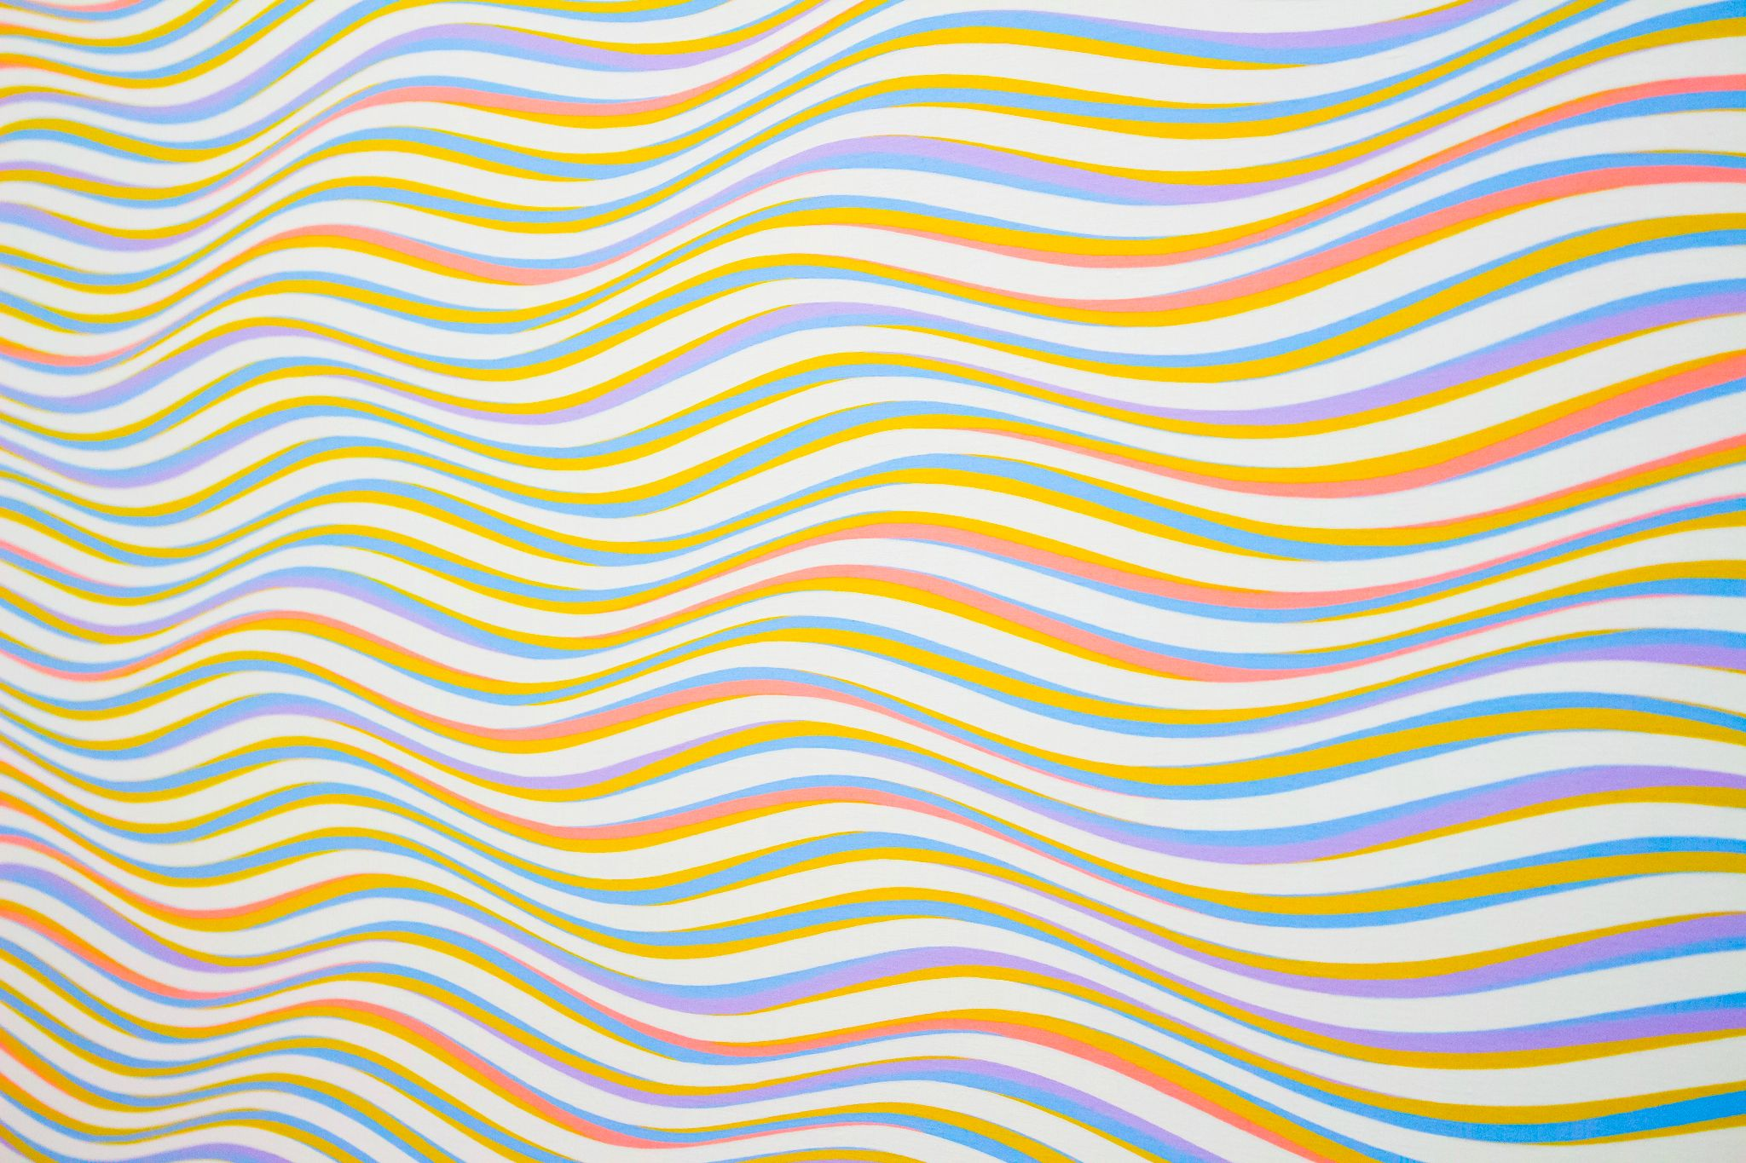

[Example](https://www.pexels.com/photo/assorted-color-striped-illustration-310452/)

/* Set entire page background to a color */

body {

background: red;

}

/* To an image URL */

body {

background: url("./images/image.png");

}

/*multiple backgrounds*/

body {

background-image: url(rose.png), url(Android-Logo.png);

background-position: right bottom, left top;

background-repeat: no-repeat, repeat;

}

/* Transparent background */

body {

background: green;

opacity: 0.5; /* 50% opacity */

}

/* Position image in center */

body {

background: center url("./images/image.png");

}

/* Repeat an image */

body {

background: repeat-x url("./images/image.png");

}

/* Don't repeat an image */

body {

background: no-repeat url("./images/image.png");

}

/* Set background for particular element with id 'my-element' */

#my-element {

background: red;

}

/* background-blend-mode */

body{

background:

radial-gradient(

red 40px,

transparent 0,

transparent 100%

),

radial-gradient(

green 40px,

transparent 0,

transparent 100%

),

radial-gradient(

blue 40px,

transparent 0,

transparent 100%

), snow;

background-blend-mode: multiply;

background-size: 100px 100px;

background-position: 0 0, 33px 33px, -33px -33px;

}

/* This demonstrates how a background image filter can be added */

body{

background-image:

conic-gradient(red, white, green, yellow, brown),

url(rose.png);

background-blend-mode: color-burn;

}



|  |
| --- |
| 1 CSS Gradient Template |
|  |

<div class="container">

<div class="square left-gradient"></div>

<div class="square right-gradient"></div>

<div class="square diagonal-gradient"></div>

<div class="square angled-gradient"></div>

<div class="square rainbow-gradient"></div>

<div class="square transparent-gradient"></div>

<div class="square repeating-gradient"></div>

<div class="square conic-gradient"></div>

<div class="square radial-gradient"></div>

<div class="square multiple-gradient"></div>

</div>

<style>

.left-gradient {

background: linear-gradient(to left, red, green);

}

/* Right-to-left gradient */

.right-gradient {

background: linear-gradient(to right, red, green);

}

/* Diagonal gradient */

.diagonal-gradient {

background: linear-gradient(to top left, red, green);

}

/* Angled (33 degree) gradient */

.angled-gradient {

background: linear-gradient(33deg, red, green);

}

/* Multi-colored gradient */

.rainbow-gradient {

background: linear-gradient(to left, red, orange, yellow, green, blue, indigo, violet);

}

/* Partially transparent gradient */

.transparent-gradient {

background: linear-gradient(to left, red, green);

opacity: 0.5;

}

.radial-gradient {

background: radial-gradient(white, yellow, brown);

}

.conic-gradient {

background: conic-gradient(red, white, green, yellow, brown);

height: 400px;

width: 400px;

}

.repeating-gradient {

height: 400px;

background-image: repeating-linear-gradient(white, yellow, brown);

}

.multiple-gradient {

background-image:

linear-gradient(to left, red, green), radial-gradient(white, yellow, brown);

}

</style>



|  |
| --- |
| 1 CSS Overflow Template |
|  |

<div class="container">

<div class="square hidden-overflow">

Lorem ipsum dolor sit amet, consectetur adipisicing elit, sed do eiusmod

tempor incididunt ut labore et dolore magna aliqua. Ut enim ad minim veniam,

quis nostrud exercitation ullamco laboris nisi ut aliquip ex ea commodo

consequat. Duis aute irure dolor in reprehenderit in voluptate velit esse

cillum dolore eu fugiat nulla pariatur. Excepteur sint occaecat cupidatat non

proident, sunt in culpa qui officia deserunt mollit anim id est laborum.

</div>

<div class="square scroll-overflow">

Lorem ipsum dolor sit amet, consectetur adipisicing elit, sed do eiusmod

tempor incididunt ut labore et dolore magna aliqua. Ut enim ad minim veniam,

quis nostrud exercitation ullamco laboris nisi ut aliquip ex ea commodo

consequat. Duis aute irure dolor in reprehenderit in voluptate velit esse

cillum dolore eu fugiat nulla pariatur. Excepteur sint occaecat cupidatat non

proident, sunt in culpa qui officia deserunt mollit anim id est laborum.

</div>

<div class="square auto-overflow">

Lorem ipsum dolor sit amet, consectetur adipisicing elit, sed do eiusmod

tempor incididunt ut labore et dolore magna aliqua. Ut enim ad minim veniam,

quis nostrud exercitation ullamco laboris nisi ut aliquip ex ea commodo

consequat. Duis aute irure dolor in reprehenderit in voluptate velit esse

cillum dolore eu fugiat nulla pariatur. Excepteur sint occaecat cupidatat non

proident, sunt in culpa qui officia deserunt mollit anim id est laborum.

</div>

<div class="square visible-overflow">

Lorem ipsum dolor sit amet, consectetur adipisicing elit, sed do eiusmod

tempor incididunt ut labore et dolore magna aliqua. Ut enim ad minim veniam,

quis nostrud exercitation ullamco laboris nisi ut aliquip ex ea commodo

consequat. Duis aute irure dolor in reprehenderit in voluptate velit esse

cillum dolore eu fugiat nulla pariatur. Excepteur sint occaecat cupidatat non

proident, sunt in culpa qui officia deserunt mollit anim id est laborum.

</div>

<div class="square visible-overflow-x">

<ol>

<li>John</li>

<li>Doe</li>

<li>Mike</li>

<li>Gee</li>

<li>Stella</li>

<li>Jane</li>

<li>Mary</li>

<li>Lawrence</li>

<li>Nancy</li>

<li>Kennedy</li>

<li>Stanely</li>

</ol>

</div>

<div class="square hidden-overflow-y">

<ol>

<li>John</li>

<li>Doe</li>

<li>Mike</li>

<li>Gee</li>

<li>Stella</li>

<li>Jane</li>

<li>Mary</li>

<li>Lawrence</li>

<li>Nancy</li>

<li>Kennedy</li>

<li>Stanely</li>

</ol>

</div>

</div>

<div class="container" style="margin-top: 10%">

<div class="rectangle overflow-wrap-normal">

This is the longest English word, Pneumonoultramicroscopicsilicovolcanoconiosis

</div>

<div class="rectangle overflow-wrap-break">

This is the longest English word, Pneumonoultramicroscopicsilicovolcanoconiosis

</div>

<div class="rectangle-max-height visible-overflow-x">

Lorem ipsum dolor sit amet, consectetur adipisicing elit, sed do eiusmod

tempor incididunt ut labore et dolore magna aliqua. Ut enim ad minim veniam,

quis nostrud exercitation ullamco laboris nisi ut aliquip ex ea commodo

consequat. Duis aute irure dolor in reprehenderit in voluptate velit esse

cillum dolore eu fugiat nulla pariatur. Excepteur sint occaecat cupidatat non

proident, sunt in culpa qui officia deserunt mollit anim id est laborum.

</div>

</div>

<div class="rectangle-max-width visible-overflow">

This is the longest English word, Pneumonoultramicroscopicsilicovolcanoconiosis

</div>

<style type="text/css">

/* visible overflow */

.container {

display: flex;

}

.square {

width: 150px;

height: 150px;

background-color: lightblue;

margin: 1em;

display: flex;

flex-direction: column;

justify-content: center;

align-items: center;

}

.rectangle {

width: 300px;

height: 50px;

background-color: lightblue;

margin: 1em;

justify-content: center;

align-items: center;

}

.rectangle-max-height{

width: 250px;

max-height: 50px;

background-color: lightblue;

margin: 1em;

justify-content: center;

align-items: center;

}

.rectangle-max-width{

max-width: 350px;

max-height: 20px;

background-color: lightblue;

margin: 1em;

}

.visible-overflow {

overflow: visible;

}

.hidden-overflow {

overflow: hidden;

}

.scroll-overflow {

overflow: scroll;

}

.auto-overflow {

overflow: auto;

}

.visible-overflow-x {

overflow-x: visible;

}

.visible-overflow-y {

overflow-y: visible;

}

.hidden-overflow-y {

overflow-y: hidden;

}

.overflow-wrap-normal {

overflow-wrap: normal;

}

.overflow-wrap-break {

overflow-wrap: break-word;

}

</style>



|  |
| --- |
| 1 CSS Animation Template |
|  |

<html>

<body>

<div class="container">

<!-- Example 1: Changing Color -->

<div class="green-square green-red-alternate"></div>

<!-- Example 2: Moving across the screen -->

<div class="black-circle vertical-alternate-fast"></div>

<!-- Example 3: On hover, changing color-->

<div class="green-rounded-square color-transition"></div>

</div>

</body>

</html>

<style>

.container {

display: flex;

flex-direction: row;

overflow: hidden;

}

/* Example 1: Changing Color */

.green-square {

width: 200px;

height: 200px;

background-color: green;

}

.green-red-alternate {

animation-name: to-red;

animation-duration: 3s;

animation-iteration-count: infinite;

animation-direction: alternate;

}

@keyframes to-red {

from {

background-color: green;

}

to {

background-color: red;

}

}

/* Example 2: Moving across the screen */

.black-circle {

width: 200px;

height: 200px;

border-radius: 100%;

background-color: black;

}

/* Example 2a: Moving horizontal slowly */

.horizontal-alternate {

animation-name: left-to-right;

animation-duration: 3s;

animation-iteration-count: infinite;

animation-direction: alternate;

}

@keyframes left-to-right {

from {

margin-left: 0%;

}

to {

margin-left: 100%;

}

}

/* Example 2b: Moving vertically quickly */

.vertical-alternate-fast {

animation-name: top-to-bottom;

animation-duration: 1s;

animation-iteration-count: infinite;

animation-direction: alternate;

}

@keyframes top-to-bottom {

from {

margin-top: 0%;

}

to {

margin-top: 100%;

}

}

/* Example 3: Animation on hover */

.green-rounded-square {

width: 200px;

height: 200px;

background-color: green;

border-radius: 1em;

}

.color-transition:hover {

animation-name: to-red;

animation-duration: 3s;

animation-iteration-count: infinite;

animation-direction: alternate;

}

</style>



|  |
| --- |
| Advanced Templates |
|  |

## FORM Example + Link to Repo

### HTML

<!--Main body of form-->

<form>

<!--Contact section of the form-->

<div class="form-elements">

<fieldset>

<legend><h2>Contact Information</h2></legend>

<label for="name">Full Name</label>

<input id="name" aria-label="name" type="text" name="name" placeholder="This field is required" required>

<label for="email">Email Address</label>

<input id="email" aria-label="email" type="email" name="email" pattern="[a-z0-9._%+-]+@[a-z0-9.-]+\.[a-z]{2,}$" placeholder="This field is required" required>

<label for="phone-number">Phone Number</label>

<input id="phone-number" aria-label="phone-number" type="tel" name="phone-number" pattern="[0-9]{3}-[0-9]{3}-[0-9]{4}" title="xxx-xxx-xxxx" placeholder="(xxx)xxx-xxxx">

<label for="address">Street Address</label>

<input id="address" aria-label="address" type="text" name="address" placeholder="1234 Elm Street">

<label for="city">City</label>

<input id="city" aria-label="city" type="text" name="city" placeholder="Haven">

<!--Select and its corresponding options and label-->

<label for="state">State</label>

<select id="state" aria-label="state" name="state">

<option value="" disabled selected >Choose State</option>

<option>Ohio</option>

<option>Michigan</option>

<option>New York</option>

<option>Florida</option>

</select>

<label for="postal-code">Postal Code</label>

<input id="postal-code" aria-label="postal-code" type="text" name="postal-code" placeholder="xxxxx">

</fieldset>

<!--Newsletter section of the form.-->

<fieldset id="newsletter">

<legend><h2>Newsletter</h2></legend>

<p>Select the newsletters you would like to recieve.</p>

<!--Checkboxes-->

<input id="html" aria-label="html" type="checkbox" name="html">

<label for="html">Html Newsletter</label>

<input id="css" aria-label="css" type="checkbox" name="css">

<label for="css">Css Newsletter</label>

<input id="jscript" aria-label="jscript" type="checkbox" name="javascript">

<label for="jscript">Javascript Newsletter</label>

<p>Newsletter format prefernce.</p>

<!--Radio buttons-->

<input id="html-format" aria-label="html-format" type="radio" name="format-choice" value="html">

<label for="html-format">Html</label>

<input id="plain-text" aria-label="plain-text" type="radio" name="format-choice" value="plain-text">

<label for="plain-text">Plain Text</label>

<p>Other topics you'd like to hear about.</p>

<!--Textarea and label-->

<label for="message"></label>

<textarea id="message" aria-label="message" name="message" placeholder="Type your messaage here."></textarea>

</fieldset>

<button type="submit">Submit</button>

</div class="form-elements">

</form>

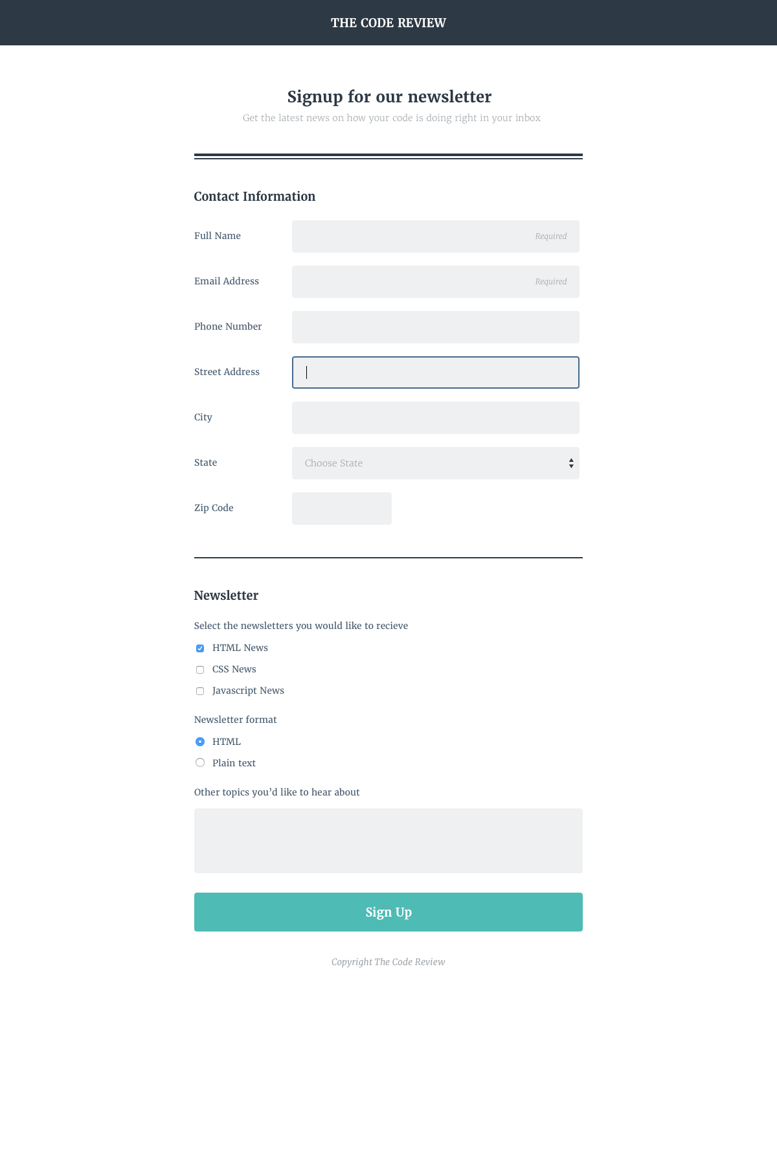

[Online Registration Form](https://github.com/HubSpotContentOffers/online-registration-form)

## SVGs and SVG symbols

### HTML

<svg id="Layer_1" xmlns="http://www.w3.org/2000/svg" display="none">

<symbol id="corgi-body">

<path class="body" d="M10.5 84.2c8.2-19.5 26.1-33.9 47.6-37.6C54.2 40.3 24.5-6.8 8.9.8-7.7 9 4 56.9 4 56.9s-1.2 14.6 6.5 27.3zM165.3 31.5c-15.4-11.2-56.4 20.2-62.8 25.2 17 11.6 28 31.3 27.3 53.3 0 1.1-.1 2.2-.2 3.3 12.8-8.1 18.9-27.9 18.9-27.9s33.5-41.8 16.8-53.9z"/>

<path class="body" d="M130.8 109.1c-1 34.6-30 61.8-64.9 60.9S3.5 140.2 4.5 105.7s30-61.8 64.9-60.9 62.4 29.7 61.4 64.3z"/>

</symbol>

<symbol id="corgi-snout-brows">

<path class="snout" d="M78.8 94.5l2.6-31.4c.6-2.3-.8-4.6-3.1-5.1-2.3-.6-4.6.8-5.2 3.1L62.6 91.4C44 92.1 29 107.3 29 125.9c-.1 19.2 15.6 34.8 34.9 34.9s35.2-15.4 35.2-34.6c.1-14-8.3-26.1-20.3-31.7z" />

<path class="brows" d="M106.9 74.7c-5.4-.8-10.1.4-10.5 2.8-.4 2.4 3.7 5 9.1 5.8 5.4.8 10.1-.4 10.5-2.8.4-2.4-3.7-5-9.1-5.8zM42.1 62.3c-5.4-.8-10.1.4-10.5 2.8-.4 2.4 3.7 5 9.1 5.8 5.4.8 10.1-.4 10.5-2.8.4-2.3-3.7-4.9-9.1-5.8z"/>

</symbol>

<symbol id="corgi-nose-eyes">

<path class="nose_and_eyes" d="M66.5 111.6c-7.1-1.1-14.3 1.2-15.5 8.3-1.1 7 4.6 13.8 11.8 15s14.7-3.5 15.8-10.6c1.1-7-5-11.5-12.1-12.7zM39.6 76c-4.1-.8-8 1.9-8.8 5.9-.8 4 1.9 7.9 5.9 8.7 4.1.8 8-1.9 8.8-5.9.9-4-1.8-7.9-5.9-8.7zM104.4 88.4c-4.1-.8-8 1.9-8.8 5.9-.8 4 1.9 7.9 5.9 8.7 4.1.8 8-1.9 8.8-5.9.9-4.1-1.8-8-5.9-8.7z"/>

</symbol>

</svg>

<svg id="white" class="corgi" xmlns="http://www.w3.org/2000/svg" viewBox="0 0 170 170">

<use class="body" href="#corgi-body" />

<use class="snout" href="#corgi-snout-brows"/>

<use class="nose_eyes" href="#corgi-nose-eyes"/>

</svg>

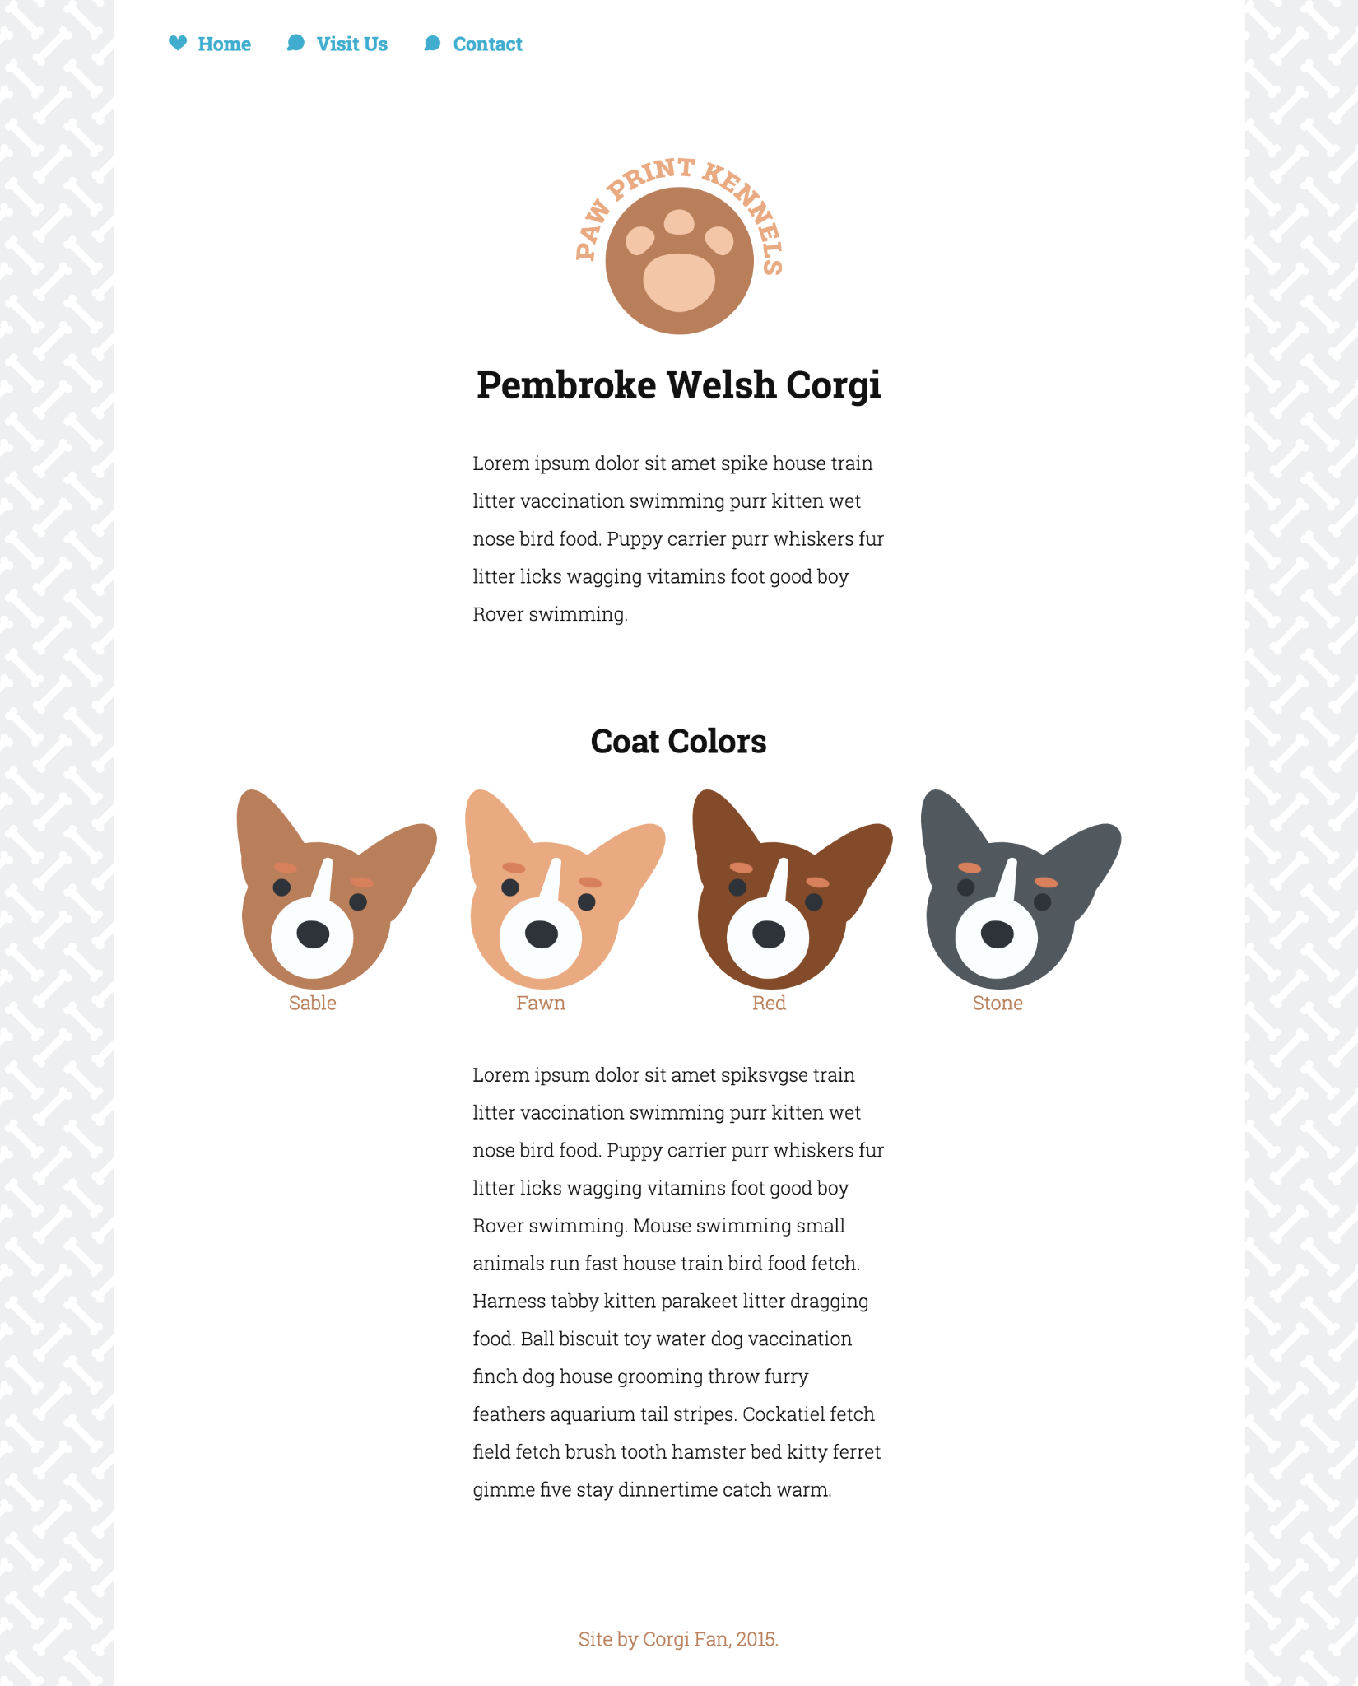

Try it out yourself: [HTML SVG Embed](https://github.com/HubSpotContentOffers/svg_update_v5)

## CSS Grid Setup

### HTML

<div class="grid__row">

<div class="grid__col--3">

<a class="link" href="/">

<img class="img--logo" alt="circles logo" src="images/logo.png">

</a>

</div>

<div class="grid__col--9">

<nav role="navigation">

<ul class="nav">

<li class="nav__item"><a href="#type">Typography</a></li>

<li class="nav__item"><a href="#buttons">Buttons</a></li>

<li class="nav__item"><a href="#forms">Form</a></li>

<li class="nav__item"><a href="#images">Images</a></li>

<li class="nav__item"><a href="#grid">Grid</a></li>

</ul>

</nav>

</div>

</div>

### CSS

[class*="grid__col--3"] {

flex: 0 25%; }

[class*="grid__col--9"] {

flex: 0 645px; }

.grid__row {

display: block; }

@media (min-width: 769px) {

.grid__row {

display: flex;

flex-direction: row;

justify-content: center; }

}

.nav__item {

list-style: none;

text-align: center;

margin: 5px;

background-color: #1b1b1b;

border-radius: 5px;

padding: 10px; }

.nav__item a {

text-decoration: none;

color: #828282; }

.nav__item:first-child {

background-color: #00819F; }

.nav__item:first-child a {

color: white; }

.nav {

display: block;

margin: auto; }

@media (min-width: 769px) {

.nav {

margin-top: 50px; }

.nav .nav__item {

display: inline-block; } }



Try it out yourself: [CSS Grid Nav Bar](https://github.com/HubSpotContentOffers/style_guide_v3)

## 

## JS Image Search Filter

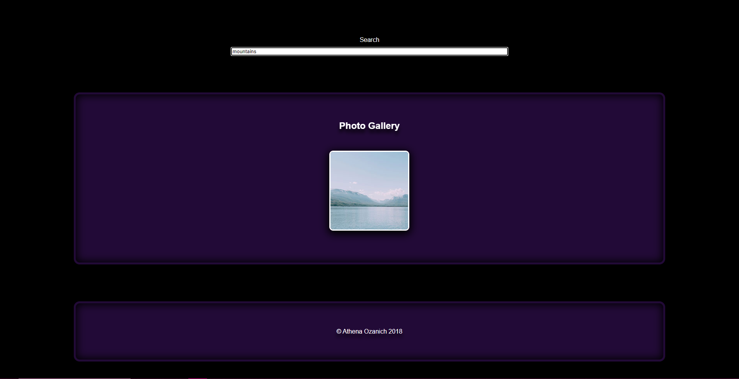

Try it out yourself: [Live Search Photo Gallery Filter](https://github.com/HubSpotContentOffers/photo_gallery)

$('#search').bind('input', function() {

var searchStr = $(this).val().toLowerCase();

$('.image').each(function() {

var str = $(this).attr("alt").toLowerCase();

var str2 = $(this).attr("caption").toLowerCase();

if(str.indexOf(searchStr) > -1) { //compares search text to title text

$(this).show(); // if the entry is found show the container

//or you can do $(this).closest('.image').show();

} else if(str2.indexOf(searchStr) > -1){

$(this).show();

}else {

$(this).hide(); // if not found, hide it.

//or you can do $(this).closest('.image').hide();

}

});

});

## CSS Templates

### Media Queries

/* Styles for larger screens */

@media screen and (min-width: 720px) {

.flex {

display: -ms-flexbox; /* TWEENER - IE 10 */

display: flex;

max-width: 1200px;

-ms-flex-pack: distribute;

justify-content: space-around;

margin: 0 auto;

}

header {

min-height: 470px;

}

.nav {

max-width: 1200px;

padding: 0 30px;

}

main {

padding-top: 20px;

}

main p {

line-height: 1.6em;

}

footer {

font-size: 1.3em;

max-width: 1200px;

margin: 40px auto;

}

}

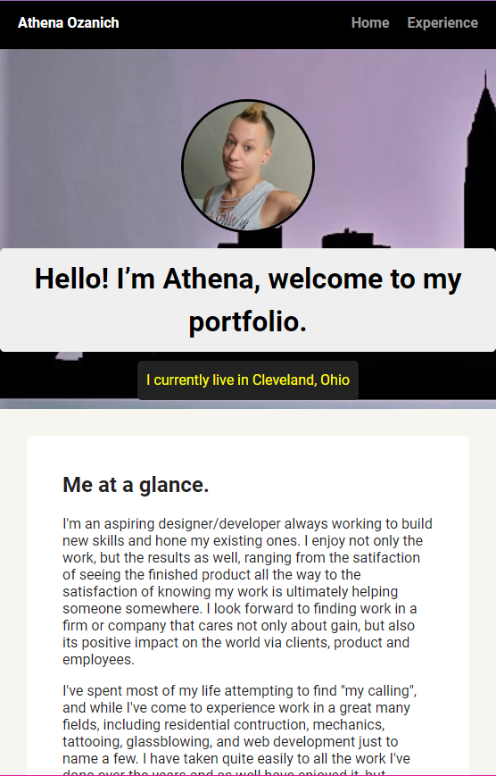

Try it out yourself: [Basic Website with Media Query](https://github.com/HubSpotContentOffers/my_site)

## 

### CSS Keyframes

@keyframes roll-in-left {

0% {

transform: translateX(-100vw) rotate(-540deg);

opacity: 0;

}

100% {

transform: translateX(0) rotate(0deg);

opacity: 1;

}

}

@keyframes roll-out-right {

0% {

transform: translateX(0px) rotate(0deg);

opacity: 1;

}

100% {

transform: translateX(100vw) rotate(540deg);

opacity: 0;

}

}

@keyframes slide-in-left {

0% {

transform: translateX(-100vw);

opacity: 0;

}

100% {

transform: translateX(0);

opacity: 1;

}

}

@keyframes slide-out-right {

0% {

transform: translateX(0);

opacity: 1;

}

100% {

transform: translateX(100vw);

opacity: 0;

}

}

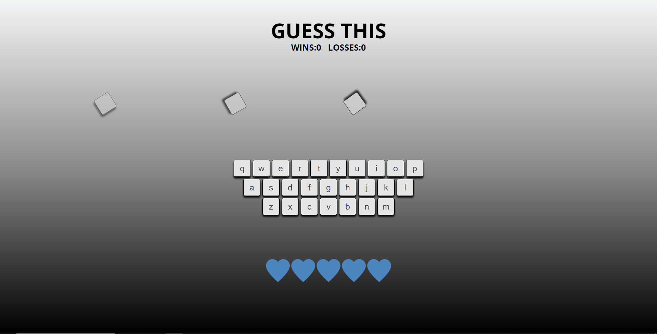

Try it out yourself: [Guessing Game Letters Animation](https://github.com/HubSpotContentOffers/game_show_app_v1)

## 

## JS Templates

### Ternary Operator

(splitPhrase[i] != ' ') ? (li.appendChild(document.createTextNode(splitPhrase[i])), li.classList.add('letter'))// Style the li

:(splitPhrase[i] == ' ')? (li.classList.add('space'), phrase.appendChild(document.createElement('UL')), word++)

:null;// Count words

### Email Validation

document.getElementById('mail').addEventListener('keyup', function(){//real-time email validation

let emailVal = document.getElementById('mail');

if(document.getElementById('mail-error')){

document.getElementById('mail-error').remove()

}

if (!emailVal.value.match(/^\w+[.]?[@][A-Za-z]+[.][A-Za-z]{3}$/)) {

let emailErrorMsg = document.createRange().createContextualFragment(

`<p id="mail-error">*ERROR: Looks like your email is either incomplete or not properly formatted!*</p>`

);

document.querySelector('form fieldset').insertBefore(emailErrorMsg, emailVal.nextSibling );

}

});

### Pagination

function showStudents(students, currPage){

for (let i = 0; i < students.length; i++) {

students[i].style.display = 'none';

if (i >= (currPage*10)-10 && i < currPage*10 ) {

students[i].style.display = 'block';

}

}

}

### Clickable Video Transcript

//select Span elements for

var transcript = document.querySelectorAll("span");

//style player and controls

video.addEventListener("timeupdate", function () {

for (var _i = 0; _i < transcript.length; _i += 1) {

transcript[_i].style.cursor = "text";

if (video.currentTime > transcript[_i].getAttribute("data-start") && video.currentTime < transcript[_i].getAttribute("data-end")) {

transcript[_i].style.color = "lightgreen";

} else {

transcript[_i].style.color = "";

}

}

});

// Click event for body text - allows jumping to that part of the video

for (var i = 0; i < transcript.length; i += 1) {

transcript[i].addEventListener("click", function (event) {

video.currentTime = event.target.getAttribute("data-start");

});

}

### Random Color Generator

//Function for generating a hex number for new random bG colors

function randomBgHex(){

let randomHex = Math.floor(Math.random()*900000) + 100000;

document.querySelector('body').style.backgroundColor = `#${randomHex}`;

}//end randomBgHex

### Random Quote Function From Array

function getRandomQuote(QuotesArray){

let random = Math.floor(Math.random() * QuotesArray.length);

let randomPhrase = QuotesArray[random];

return randomPhrase;

}//end getRandomQuote